QH-TRIP | Translating Research Into Practice

Implementation Masterclass
Module 7: Sustainability, Scale and Spread
Participant Handbook
  - 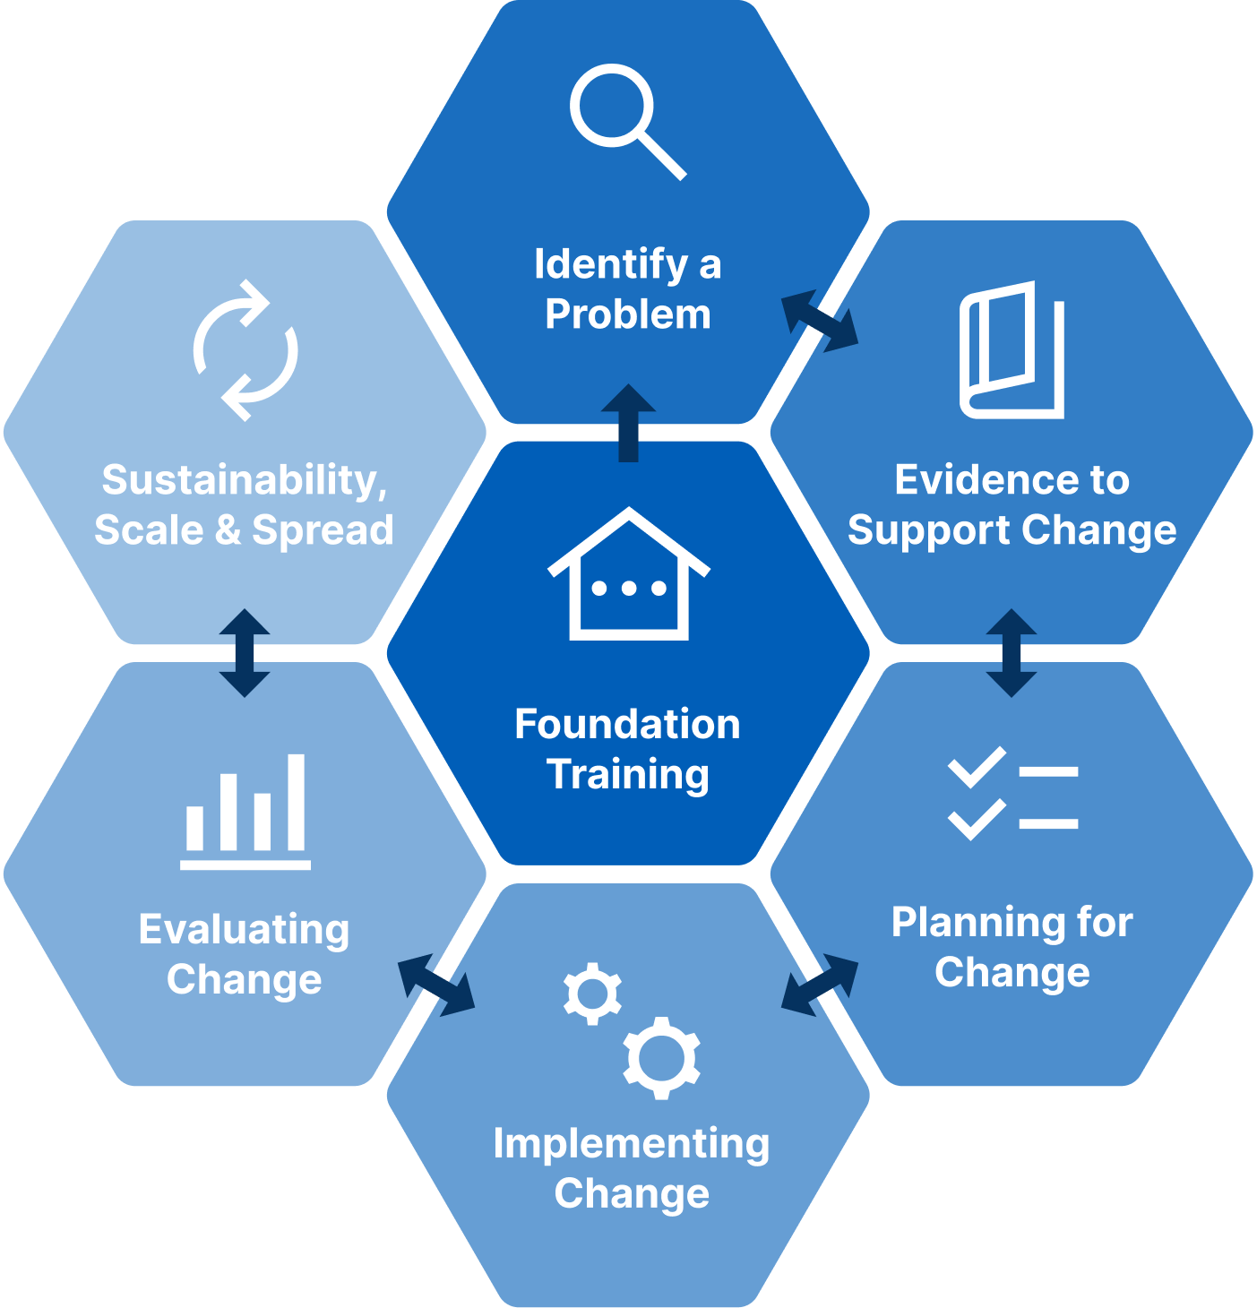

Implementation Masterclass Module 7: Sustainability, Scale and Spread Participant Handbook
Published by the State of Queensland (Queensland Health), June 2026

This document is licensed under a Creative Commons Attribution 4.0 International licence (CC BY 4.0). To view a copy of this licence, visit creativecommons.org/licenses/by/4.0/
You are free to copy, communicate and adapt the work, as long as you attribute the State of Queensland (Queensland Health).
For more information contact:
Office of the Chief Allied Health Officer (OCAHO), Health Workforce Division, Queensland Health, GPO Box 48, Brisbane QLD 4001, email allied_health_advisory@health.qld.gov.au, phone (07) 3328 9928.
Disclaimer
The content presented in this publication is distributed by the Queensland Government as an information source only. The State of Queensland makes no statements, representations or warranties about the accuracy, completeness of any information contained in this publication. The State of Queensland disclaims all responsibility and all liability (including without limitation for liability in negligence) for all expenses, losses, damages and costs you might incur as a result of the information.

Table of Contents
Prelude 4
Helpful links and resources 5
Sustainability 5
Facilitation 5
Diffusion of Innovation 5
Sustainability planning 5
Presentation slides 6
Appendix 17
A.1 Activity 1: Review key sustainability components (case study) 18
A.2 Activity 2: Spread improvement to a similar setting (TRIP) 19
A.3 Reflection: Application to local context 20

Prelude
Welcome to final module of the Implementation Masterclass.
Module 7 brings the program together by shifting attention from implementing change in one setting to embedding improvement over time and exploring how it might be spread to other contexts. It reinforces that sustainability is not a separate end stage, but considerations have been built into planning, monitoring, and adaptation from the start.
Sustainability is described as a dynamic process in which implementation processes and strategies adapt to support interventions across different contexts. The implementation literature distinguishes spread, as local diffusion, from scale-up, as a deliberate expansion. The case study used throughout these modules is again used, to show how change was spread and sustained across the state.
You may arrive at this module with a strong desire to “finish well” by completing a plan. Instead, focus on understanding and adapting implementation strategies to new and different contexts, alongside local stakeholders.
This module also offers an opportunity to look ahead to practice settings where future implementation might occur. Look for important problems to apply what you have learned and seek mentors and potential research and peer collaborators to work with.
By the end of this module, you should be confident to recognise opportunities to embed implementation efforts over time and think strategically about how improvements can be adapted and spread responsibly within complex health systems.

Thank you for your engagement throughout the Implementation Masterclass.

Helpful links and resources
The following articles, blogs, videos, podcasts and websites provide useful information to support your learning. You do not need to read all resources before commencing the module.
Sustainability | Sustainability: What is it? Why is it important? How are readiness, context, and sustainability related? (Moore, 2023). The Center for Implementation.
Sustainability | Developing a comprehensive definition of sustainability. (Moore et al., 2017).
Facilitation | Introducing an interactional approach to exploring facilitation as an implementation intervention: examining the utility of Conversation Analysis. (Hunter et al., 2020).
Facilitation | Sustaining implementation facilitation: a model for facilitator resilience. (Olmos-Ochoa et al., 2021).
Facilitation | Project Spotlight: The use of implementation facilitators as multifaceted implementation strategy to support the implementation of complex interventions. (Dollar et al., 2020). The Center for Implementation.
Diffusion of Innovation | Diffusion of innovations theory, principles, and practice. (Dearing & Cox, 2018).
Diffusion of Innovation | K4Health Theory Primer: Diffusion of Innovations. (John Hopkins University, 2015).
Sustainability planning | Solutions for sustainability planning: the long term success tool. (Moore, 2020). The Center for Implementation.

Presentation slides
Slide | Notes
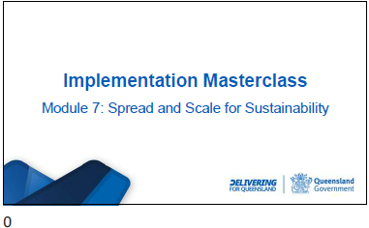

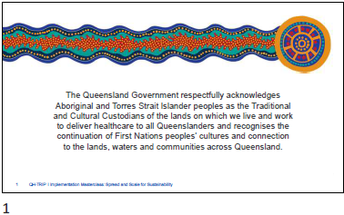

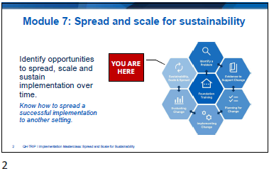

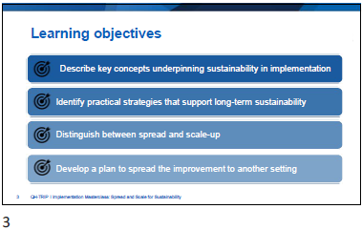

Slide | Notes
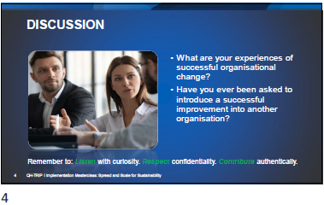

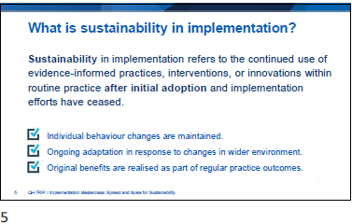

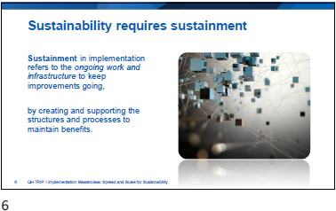

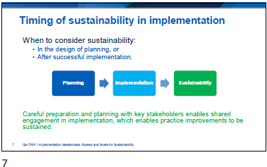

Slide | Notes
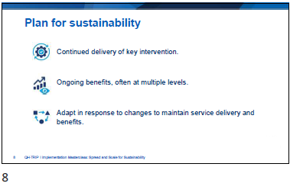

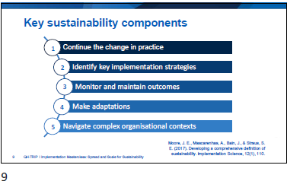

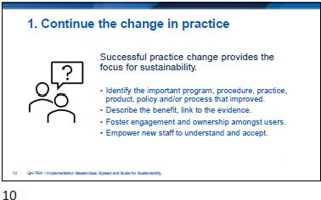

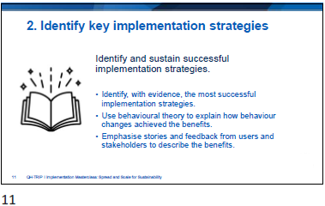

Slide | Notes
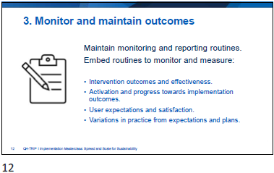

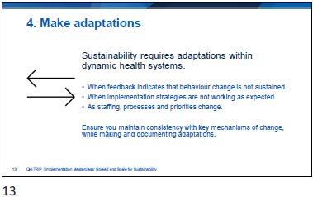

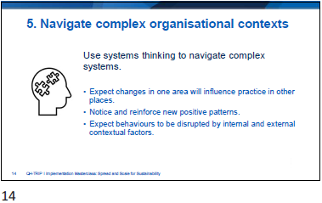

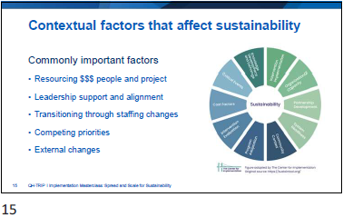

Slide | Notes
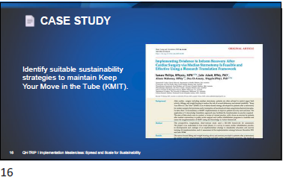

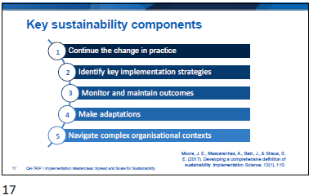
Activity 1: Review key sustainability components (case study)
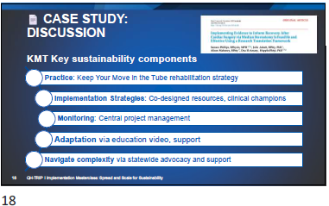

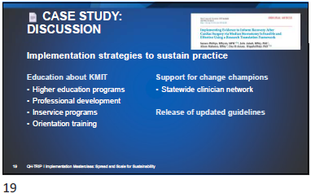

Slide | Notes
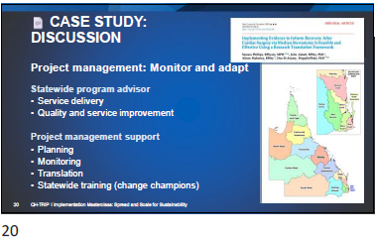

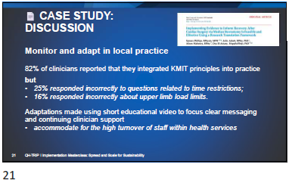

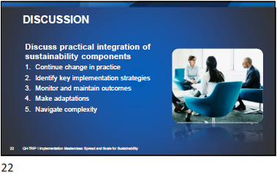

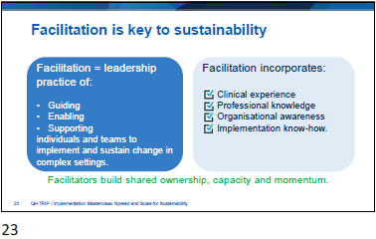

Slide | Notes
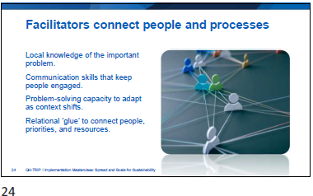

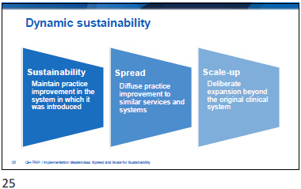

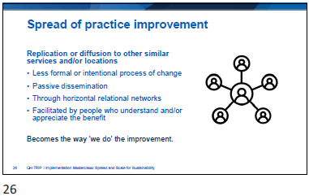

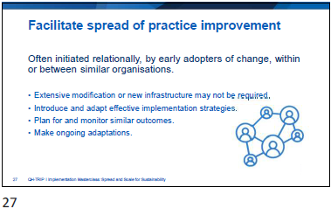

Slide | Notes
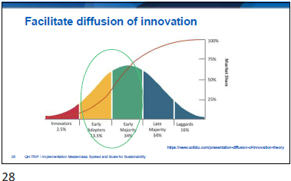

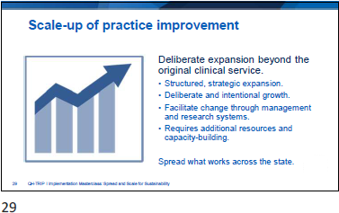

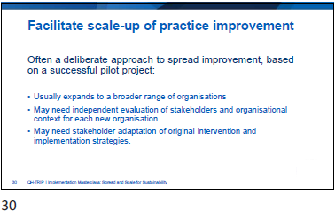

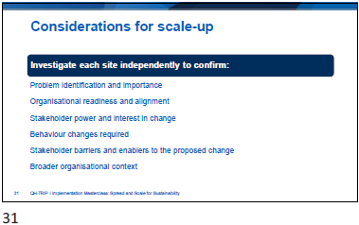

Slide | Notes
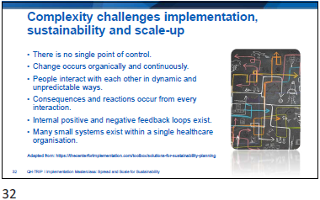

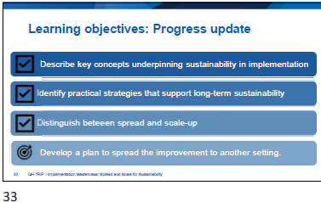

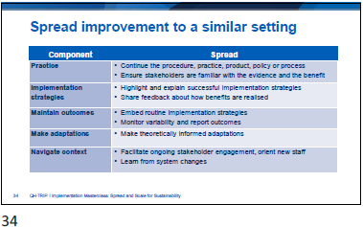

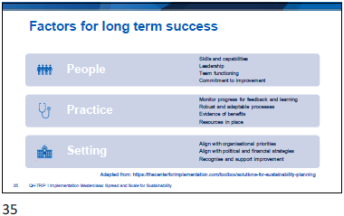

Slide | Notes
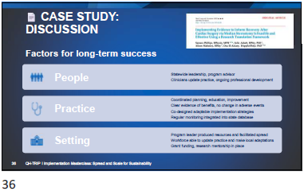

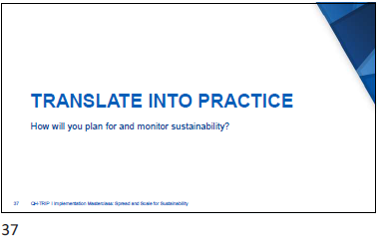
Activity 2: Spread improvement to a similar setting (TRIP)
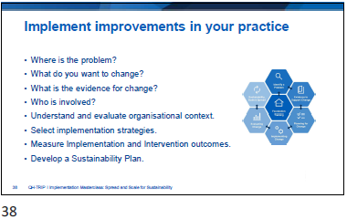

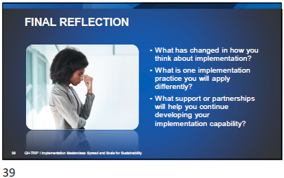

Slide | Notes
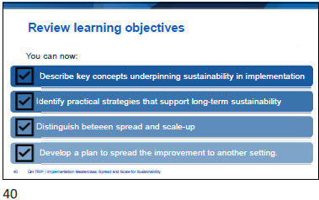

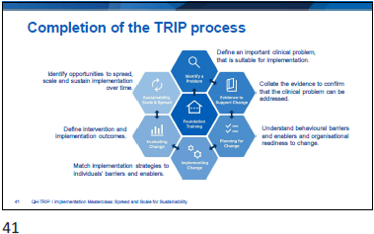

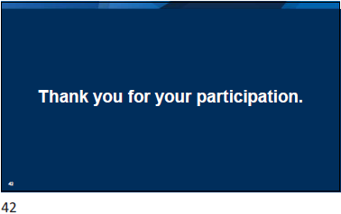

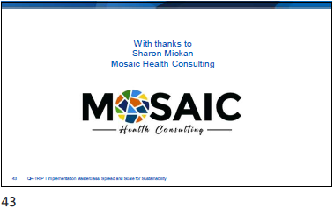

Slide | Notes
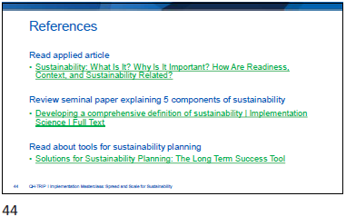

Appendix
- Activity 1: Review key sustainability components (case study)
- Activity 2: Spread improvement to a similar setting (TRIP)
- Reflection: Application to local context

  - Activity 1: Review key sustainability components (case study)

Component | Application
Continue the change in practice
Identify key implementation strategies
Monitor and maintain outcomes
Make adaptations
Navigate complex organisational contexts

  - Activity 2: Spread improvement to a similar setting (TRIP)

Component | Spread | Apply to practice
Continue the change in practice | - Continue the procedure, practice, product, policy or process.  - Ensure stakeholders are familiar with the evidence and the benefit.
Identify key implementation strategies | - Highlight and explain successful implementation strategies.  - Share feedback about how benefits are realised.
Monitor and maintain outcomes | - Embed routine implementation strategies.  - Monitor variability and report outcomes.
Make adaptations | - Make theoretically informed adaptations.
Navigate complex organisational contexts | - Facilitate ongoing stakeholder engagement, orient new staff.  - Learn from system changes.

  - Reflection: Application to local context

- Where is the Problem?
- What do you want to change?
- What is the evidence for the change?
- Who is involved?
- Describe organisational context and readiness for change.
- Select implementation strategies.
- Develop a sustainability plan.

