QH-TRIP | Translating Research Into Practice

Implementation Masterclass
Module 6: Evaluating Change
Participant Handbook
  - 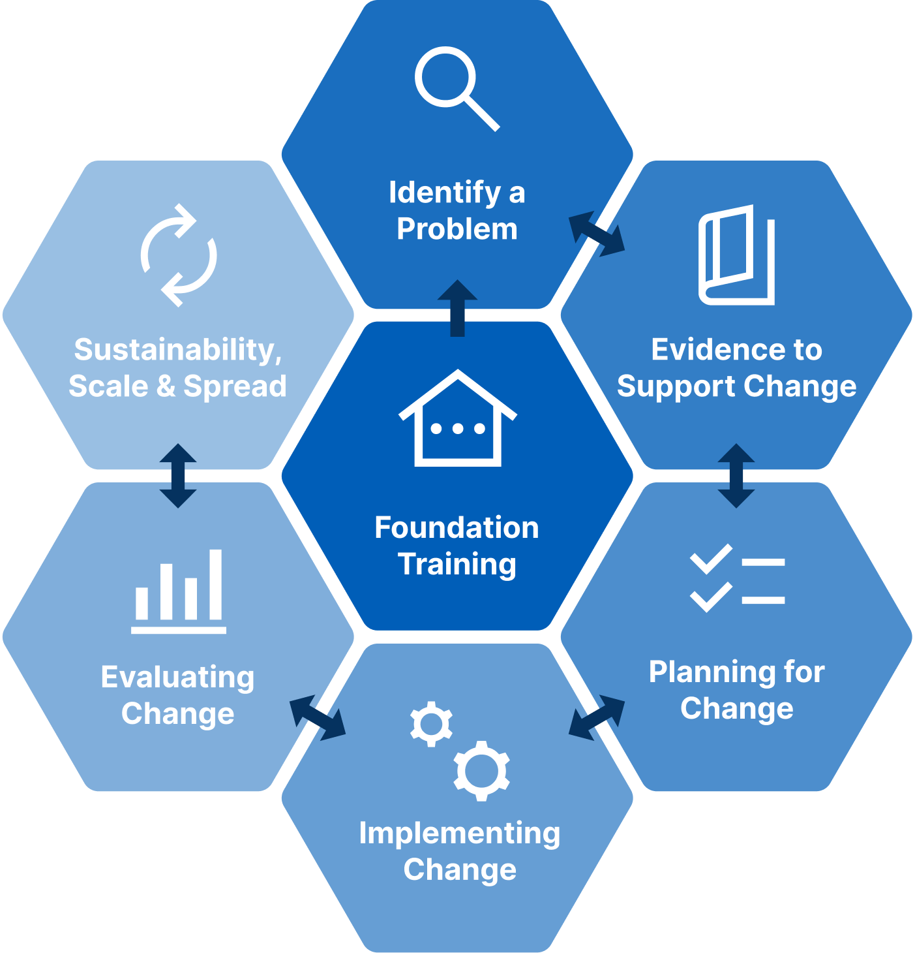

Implementation Masterclass Module 6: Evaluating Change Participant Handbook
Published by the State of Queensland (Queensland Health), June 2026

This document is licensed under a Creative Commons Attribution 4.0 International licence (CC BY 4.0). To view a copy of this licence, visit creativecommons.org/licenses/by/4.0/
You are free to copy, communicate and adapt the work, as long as you attribute the State of Queensland (Queensland Health).
For more information contact:
Office of the Chief Allied Health Officer (OCAHO), Health Workforce Division, Queensland Health, GPO Box 48, Brisbane QLD 4001, email allied_health_advisory@health.qld.gov.au, phone (07) 3328 9928.
Disclaimer
The content presented in this publication is distributed by the Queensland Government as an information source only. The State of Queensland makes no statements, representations or warranties about the accuracy, completeness of any information contained in this publication. The State of Queensland disclaims all responsibility and all liability (including without limitation for liability in negligence) for all expenses, losses, damages and costs you might incur as a result of the information.

Table of Contents
Prelude 4
Helpful links and resources 5
Outcome measurement 5
Implementation outcomes as process evaluation 5
Intervention vs. implementation outcomes 5
RE-AIM 5
Presentation slides 6
Appendix 20
A.1 Activity 1: Follow the logic (case study) 21
A.2 Activity 1: Follow the logic (case study) – cont. 22
A.3 Activity 2: Consider the components of a logic model (TRIP) 23
A.4 Activity 3: Identify RE-AIM outcomes and results (case study) 24
A.5 Activity 4: Identify RE-AIM measures (TRIP) 25
A.6 Reflection: Application to local context 26
A.7 Template: Practical Guide for Implementation Outcomes 27
A.8 Template: Clarify Components of a Logic Model 28

Prelude
Welcome to Module 6 of the Implementation Masterclass.
This module shifts our focus from planning implementation to understanding whether change is occurring and how we can demonstrate that change to others. It continues to build on the progressive planning from earlier modules and focuses on determining practical ways to distinguish between and measure intervention and implementation outcomes.
In this module, you are encouraged to move beyond matching and monitoring implementation strategies to support behaviour change, and to determine ways to evaluate the success of both the intervention and the implementation strategies that support its introduction into routine practice.
You will explore how practical measurement approaches can be developed with implementation teams and stakeholders, fostering a sense of shared ownership that strengthens implementation outcomes. The case study illustrates how measurement choices were shaped and enacted.
This module also continues and finalises the development of the logic model. You will examine how early decisions about what to monitor and how to measure those actions connect to intervention and implementation outcomes, ultimately influencing the impact of change.
By the end of this module, you should have greater confidence in moving from analysis to measurement and evaluation, and in working collaboratively with teams and stakeholders to support implementation over time, including addressing common questions about evaluation planning.

Helpful links and resources
The following articles, blogs, videos, podcasts and websites provide useful information to support your learning. You do not need to read all resources before commencing the module.
Outcome measurement | Outcomes for implementation research: conceptual distinctions, measurement challenges, and research agenda. (Proctor et al., 2011).
Implementation outcomes as process evaluation | Process evaluation of complex interventions: Medical Research Council guidance. (Moore et al., 2015).
Intervention vs. implementation outcomes | Implementation science made too simple: a teaching tool. (Curran, 2020).
RE-AIM | What is RE-AIM? (re-aim.org)
RE-AIM | The RE-AIM Framework: a systematic review of use over time. (Gaglio, Shoup, & Glasgow, 2013).
RE-AIM | RE-AIM planning and evaluation framework: adapting to new science and practice with a 20-year review. (Glasgow et al., 2019).
RE-AIM | Use of RE-AIM to develop a multi-media facilitation tool for the patient-centered medical home. (Glasgow et al., 2011).

Presentation slides
Slide | Notes
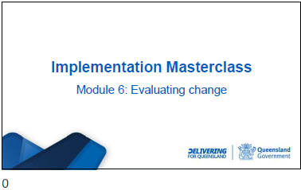

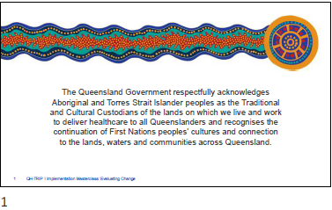

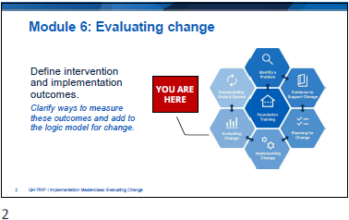

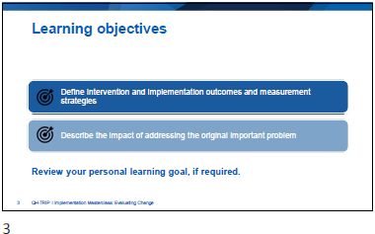

Slide | Notes
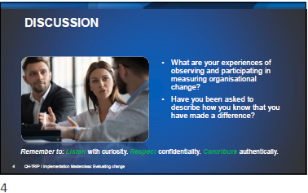

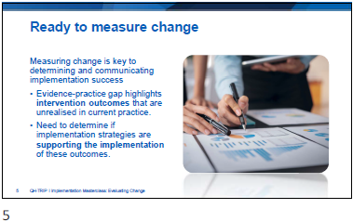

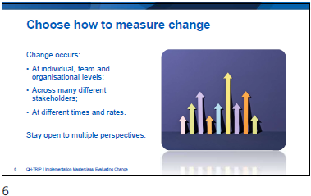

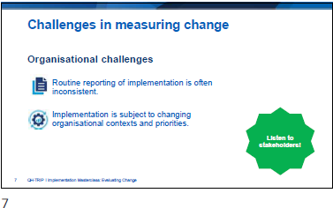

Slide | Notes
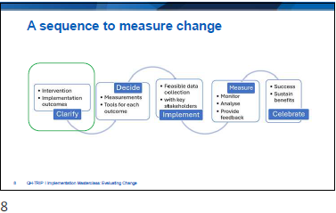

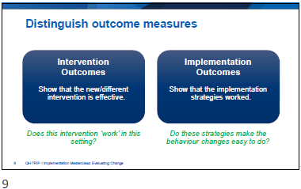

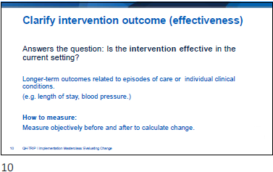

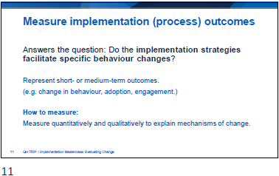

Slide | Notes
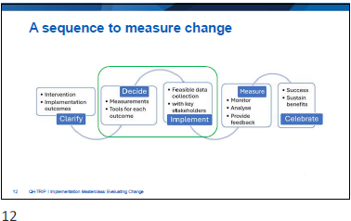

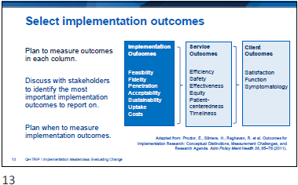

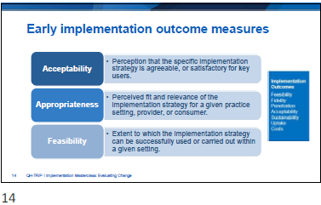

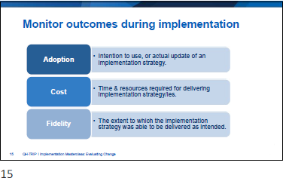

Slide | Notes
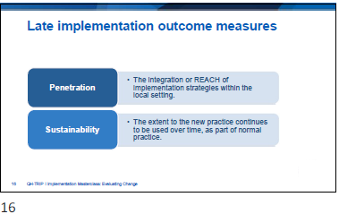

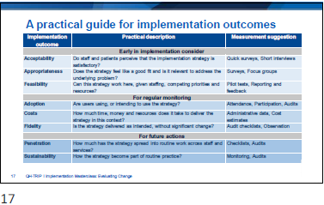

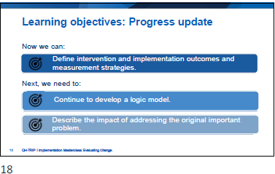

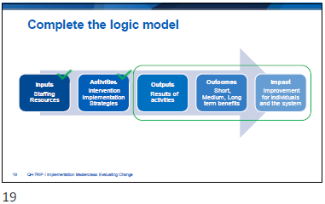

Slide | Notes
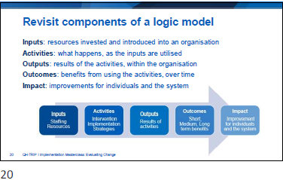

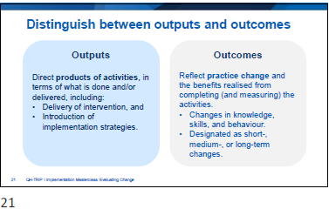

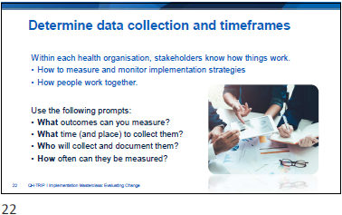

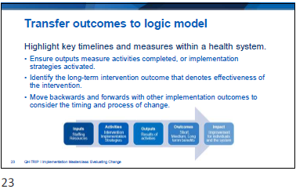

Slide | Notes
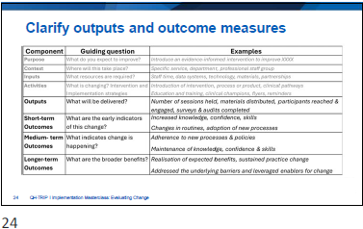

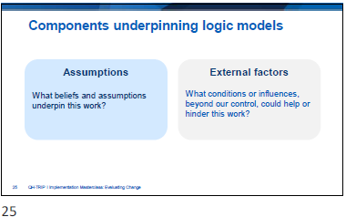

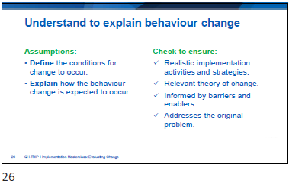

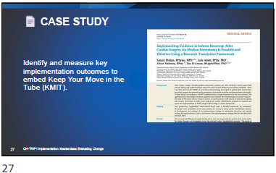

Slide | Notes
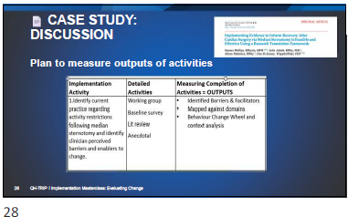

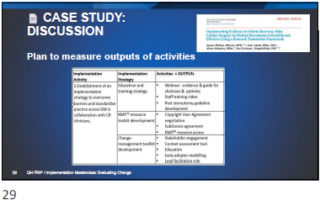

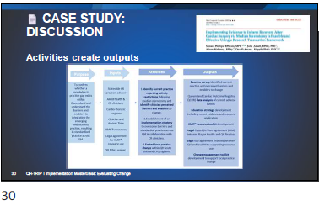
Activity 1: Follow the logic (case study)
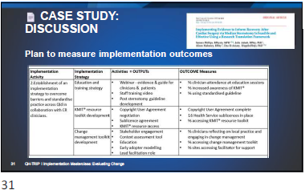

Slide | Notes
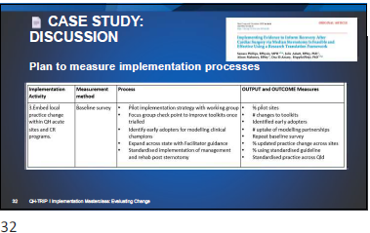

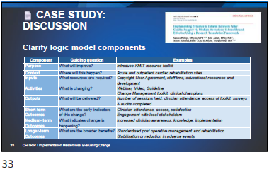

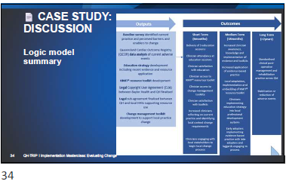

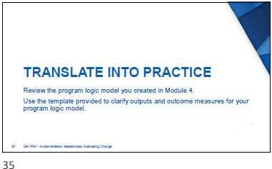
Activity 2: Consider the components of a logic model (TRIP)

Slide | Notes
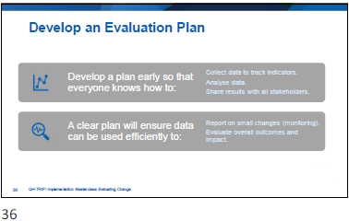

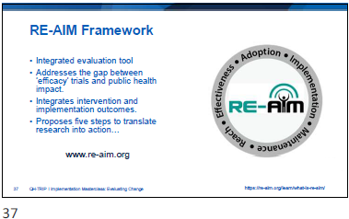

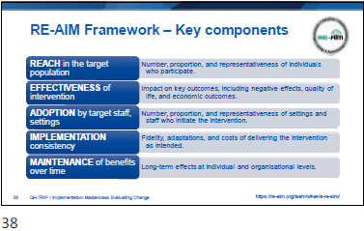

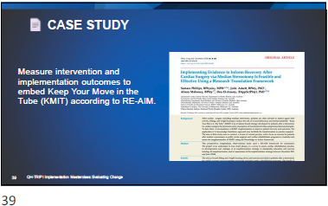

Slide | Notes
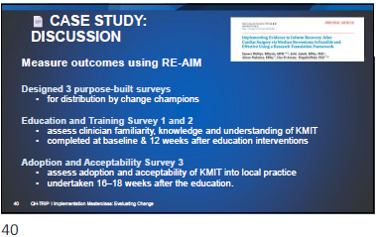

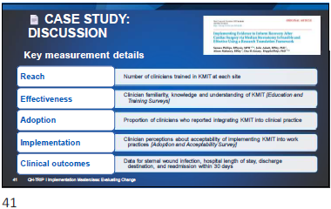
Activity 3: Identify RE-AIM outcomes and results (case study)
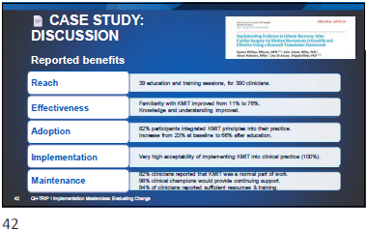

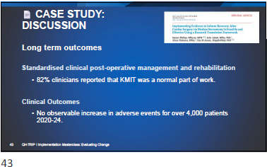

Slide | Notes
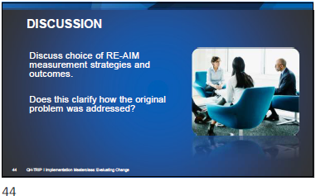

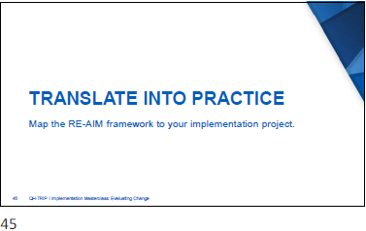
Activity 4: Identify RE-AIM measures (TRIP)
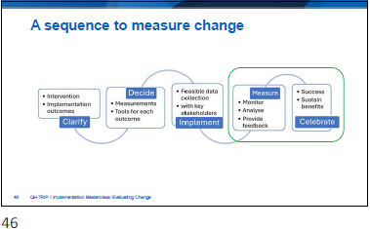

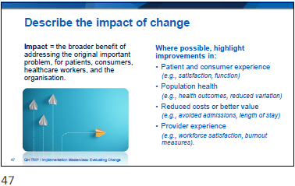

Slide | Notes
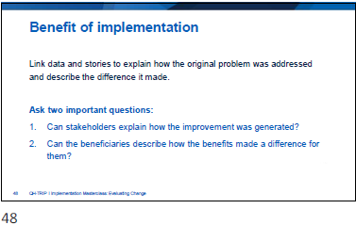

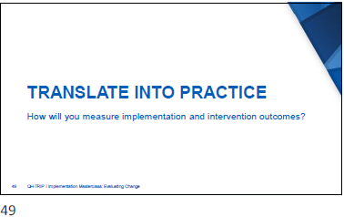

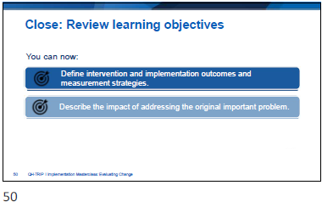

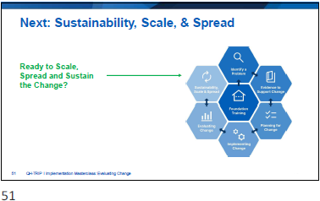

Slide | Notes
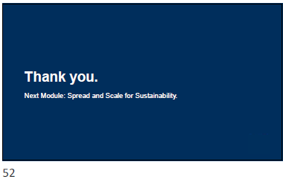

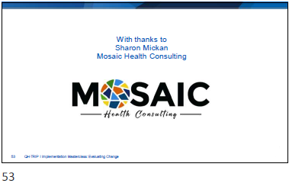

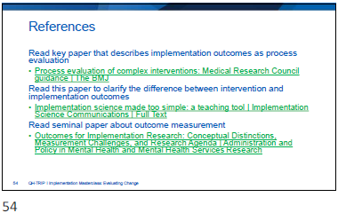

Appendix
- Activity 1: Follow the logic (case study)
- Activity 2: Consider the components of a logic model (TRIP)
- Activity 3: Identify RE-AIM outcomes and results (case study)
- Activity 4: Identify RE-AIM measures (TRIP)
- Reflection: Application to local context
- Template: Practical Guide for Implementation Outcomes
- Template: Clarify Components of a Logic Model

  - Activity 1: Follow the logic (case study)
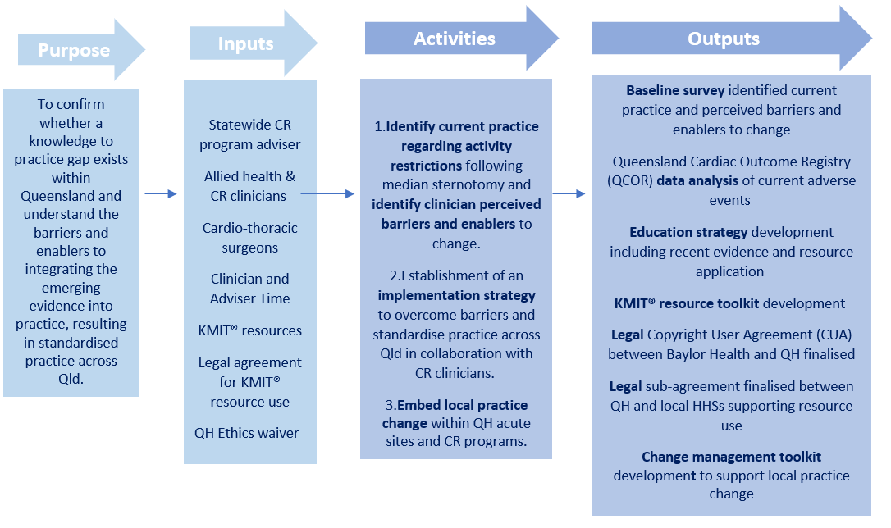
  - Activity 1: Follow the logic (case study) – cont.
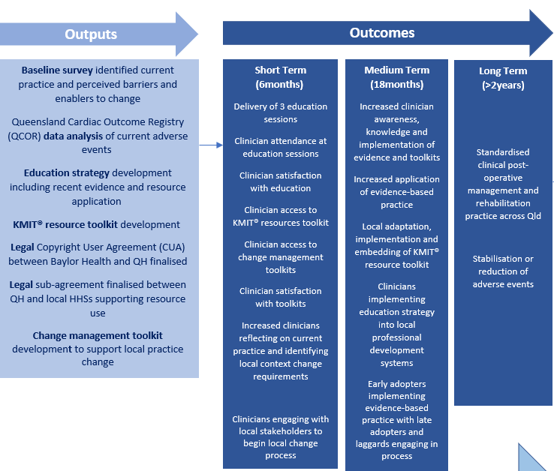
  - Activity 2: Consider the components of a logic model (TRIP)
Component | Guiding question | Examples | Apply to practice
Inputs | What resources are required? | Staff time, data systems, technology, materials, partnerships.
Activities | What is changing?  Intervention and Implementation strategies | Introduction of intervention, process or product, clinical pathways.  Education and training, clinical champions, flyers, reminders.
Outputs | What will be delivered? | Number of sessions held, materials distributed, participants reached and engaged, surveys and audits completed.
Short-term Outcomes | What are the early indicators of this change? | Increased knowledge, confidence, skills.  Changes in routines, adoption of new processes.
Medium- term Outcomes | What indicates change is happening? | Adherence to new processes and policies.  Maintenance of knowledge, confidence and skills.
Longer-term Outcomes | What are the broader benefits? | Realisation of expected benefits, sustained practice change.  Addressed the underlying barriers and leveraged enablers for change.

  - Activity 3: Identify RE-AIM outcomes and results (case study)

RE-Aim Component | Descriptor | Case Study results
Reach | Number of clinicians trained in KMIT at each site.
Effectiveness | Clinician familiarity, knowledge and understanding of KMIT.
Adoption | Proportion of clinicians who reported integrating KMIT into clinical practice.
Implementation | Clinician perceptions of acceptability implementing KMIT.
Maintenance of Clinical Outcomes | Data for sternal wound infection, length of stay, discharge destination, readmission in 30 days.

  - Activity 4: Identify RE-AIM measures (TRIP)

RE-Aim Component | Outcome measure
Reach
Effectiveness
Adoption
Implementation
Maintenance of Clinical Outcomes

  - Reflection: Application to local context

- Where is the Problem?
- What do you want to change?
- What is the evidence for the change?
- Who is involved?
- Describe organisational context and readiness for change.
- Select implementation strategies.
- Measure implementation and intervention outcomes

  - Template: Practical Guide for Implementation Outcomes

Implementation outcome | Practical description | Measurement suggestion
Early in implementation, consider…

Acceptability | Do staff and patients perceive that the implementation strategy is satisfactory? | Quick surveys  Short interviews
Appropriateness | Does the strategy feel like a good fit and is it relevant to address the underlying problem? | Surveys  Focus groups
Feasibility | Can this strategy actually work here, given staffing, competing priorities & resources? | Pilot tests  Reporting and feedback
For regular monitoring…

Adoption | Are users using, or intending to use the strategy? | Attendance, participation Audits of usage
Costs | How much time, money and resources does it take to deliver the strategy in this context? | Administrative data  Cost estimates
Fidelity | Is the strategy delivered as intended, without significant change? | Audit checklists  Observation
For future actions…

Penetration | How much has the strategy spread into routine work across staff and services? | Checklists  Audits
Sustainability | How the strategy becomes part of routine practice? | Monitoring  Audits

  - Template: Clarify Components of a Logic Model

Component | Guiding question | Examples
Purpose | What do you expect to improve? | Introduce an evidence-informed intervention to improve XXXX.
Context | Where will this take place? | Specific service, department, professional staff group.
Inputs | What resources are required? | Staff time, data systems, technology, materials, partnerships.
Activities | What is changing?  Intervention and Implementation strategies | Introduction of intervention, process or product, clinical pathways.  Education and training, clinical champions, flyers, reminders.
Outputs | What will be delivered? | Number of sessions held, materials distributed, participants reached and engaged, surveys and audits completed.
Short-term Outcomes | What are the early indicators of this change? | Increased knowledge, confidence, skills.  Changes in routines, adoption of new processes.
Medium- term Outcomes | What indicates change is happening? | Adherence to new processes and policies.  Maintenance of knowledge, confidence and skills.
Longer-term Outcomes | What are the broader benefits? | Realisation of expected benefits, sustained practice change.  Addressed the underlying barriers and leveraged enablers for change.

