QH-TRIP | Translating Research Into Practice

Implementation Masterclass
Module 5: Implementing Change
Participant Handbook
  - 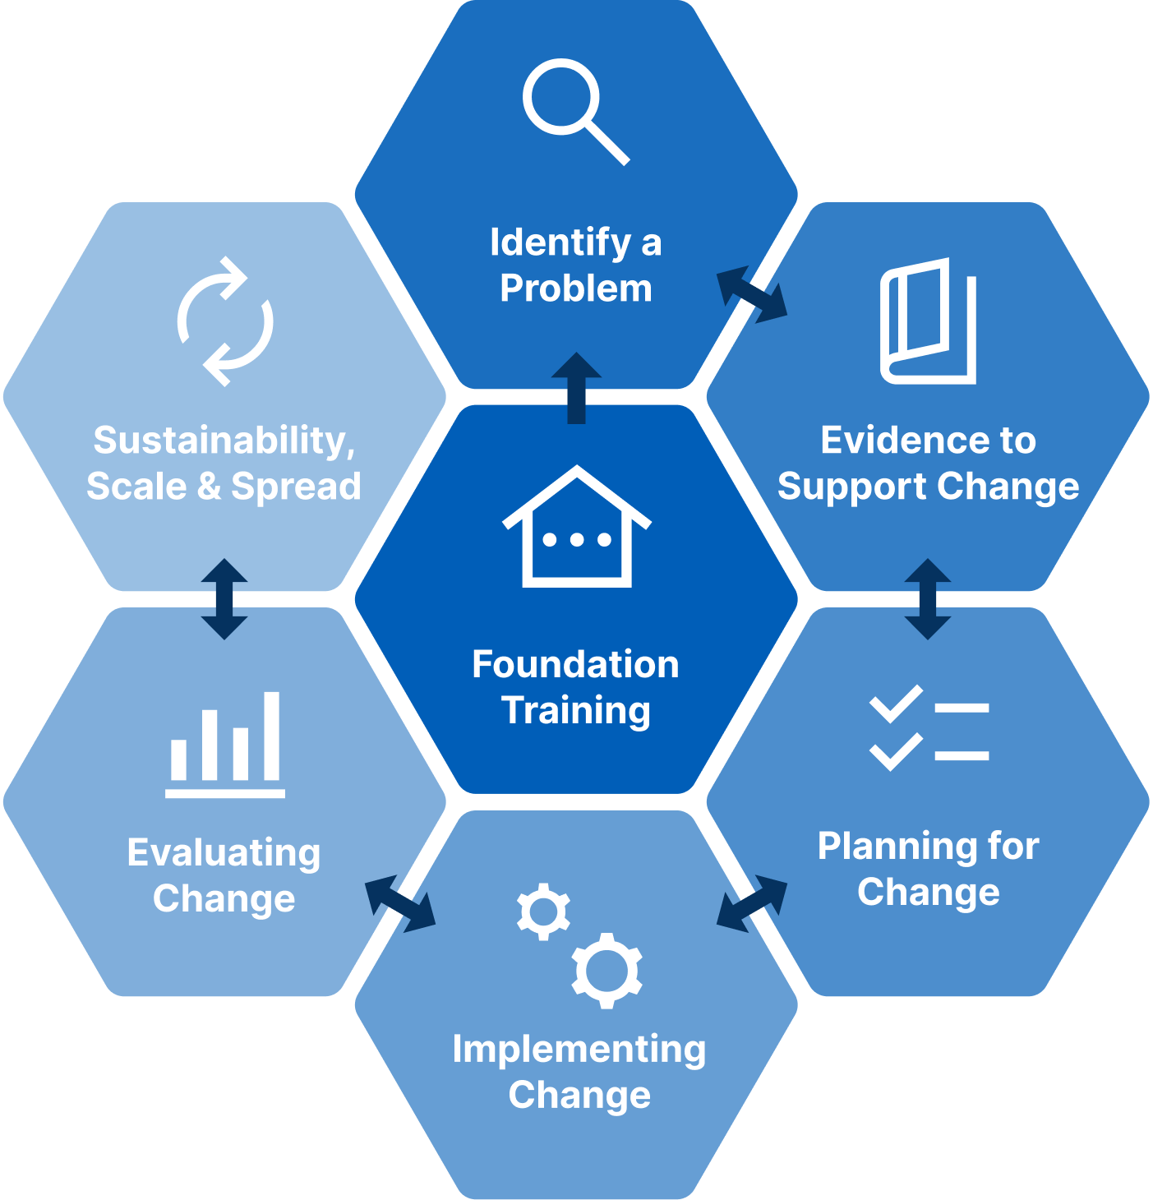

Implementation Masterclass Module 5: Implementing Change Participant Handbook
Published by the State of Queensland (Queensland Health), June 2026

This document is licensed under a Creative Commons Attribution 4.0 International licence (CC BY 4.0). To view a copy of this licence, visit creativecommons.org/licenses/by/4.0/
You are free to copy, communicate and adapt the work, as long as you attribute the State of Queensland (Queensland Health).
For more information contact:
Office of the Chief Allied Health Officer (OCAHO), Health Workforce Division, Queensland Health, GPO Box 48, Brisbane QLD 4001, email allied_health_advisory@health.qld.gov.au, phone (07) 3328 9928.
Disclaimer
The content presented in this publication is distributed by the Queensland Government as an information source only. The State of Queensland makes no statements, representations or warranties about the accuracy, completeness of any information contained in this publication. The State of Queensland disclaims all responsibility and all liability (including without limitation for liability in negligence) for all expenses, losses, damages and costs you might incur as a result of the information.

Table of Contents
Prelude 4
Helpful links and resources 5
Mechanisms of change 5
Theory-informed behaviour change 5
Behaviour Change Technique 5
Behaviour Change Wheel 5
ERIC 5
CFIR-ERIC tools 5
Presentation slides 6
Appendix 17
A.1 Reflection: Application to local context 18
A.2 Template: Sequence of Behavioural Analysis 19
A.3 Template: Mechanisms of Change inform implementation strategies 20
A.4 Template: Select appropriate intervention functions 21
A.5 Template: QH-TRIP Program Logic Model 22

Prelude
Welcome to Module 5 of the Implementation Masterclass.
This module represents another shift in the program from analysing problems, behaviour, and context to actively planning how implementation will be supported in practice. It brings together insights from earlier modules and focuses on synthesising this information into deliberate, workable implementation strategies.
In this module, you are encouraged to integrate what you have learned about the evidence–practice gap, behavioural barriers and enablers, organisational context, and stakeholder perspectives. The emphasis is on using this combined understanding to select implementation strategies that are well matched to local needs, and that support behavioural changes, rather than defaulting to familiar or generic approaches.
You will be guided to explore how implementation strategies are developed collaboratively with the implementation team and key stakeholders, recognising that shared ownership strengthens feasibility, acceptability, and sustainability. The shared case study is used to illustrate how strategy choices were shaped through engagement, negotiation, and refinement.
This module also introduces monitoring as a core planning activity. You will examine how early decisions about what to monitor, and how to learn from that information, support timely adaptation as implementation unfolds.
By the end of this module, you should feel more confident moving from analysis to action, and in working collaboratively with teams and stakeholders to support implementation over time.

Helpful links and resources
The following articles, blogs, videos, podcasts and websites provide useful information to support your learning. You do not need to read all resources before commencing the module.
Mechanisms of change | Mechanism mapping to advance research on implementation strategies (Geng, Baumann, & Powell, 2022).
Mechanisms of change | The Improved Clinical Effectiveness through Behavioural Research Group (ICEBeRG) Designing theoretically-informed implementation interventions (2026).
Theory-informed behaviour change | Developing theory-informed behaviour change interventions to implement evidence into practice: a systematic approach using the Theoretical Domains Framework (French et al., 2012).
Behaviour Change Technique | BCT Taxonomy (digitalwellbeing.org)
Behaviour Change Technique | Human Behaviour-Change Project (including the APRICOT project).
Behaviour Change Technique | The Behaviour Change Technique ontology: transforming the Behaviour Change Technique taxonomy v1 (Marques et al., 2024).
Behaviour Change Technique | Designing interventions to change eating behaviours (Atkins & Michie, 2015).
Behaviour Change Wheel | The Behaviour Change Wheel: A Guide to Designing Interventions (Michie, Atkins, & West, 2014).
Behaviour Change Wheel | The COM-B Model for Behaviour Change. The Decision Lab.
Behaviour Change Assessment Tool | CACTIS Tool v1.7.2 (Unlocking Behaviour Change CIC)
ERIC | A refined compilation of implementation strategies: results from the Expert Recommendations for Implementing Change (ERIC) project (Powell et al., 2015).
ERIC | A refined compilation of implementation strategies: results from the Expert Recommendations for Implementing Change (ERIC) project – pdf list of strategies.
CFIR-ERIC tools | CFIR Guidance & Tools (cfirguide.org)
CFIR-ERIC tools | CFIR-ERIC Implementation Strategy Matching Tool (National Collaborating Centre for Methods and Tools).

Presentation slides
Slide | Notes
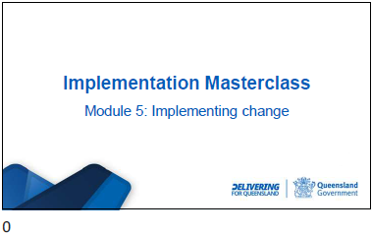

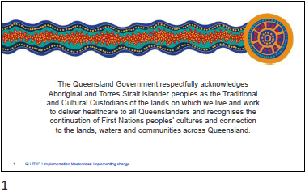

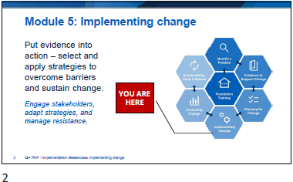

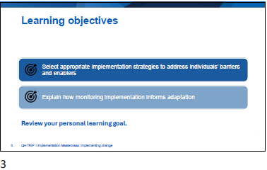

Slide | Notes
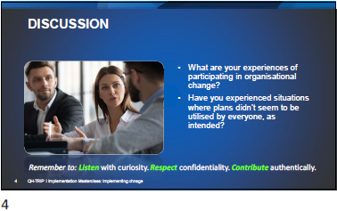

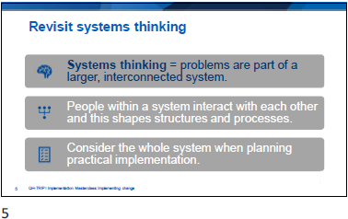

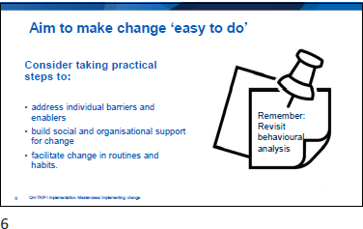

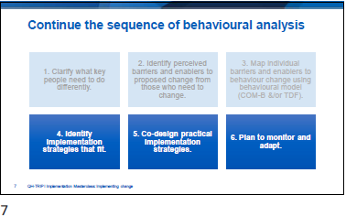

Slide | Notes
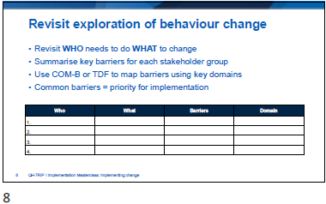

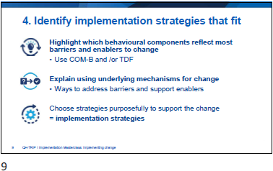

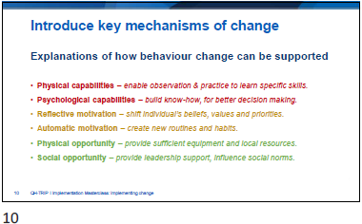

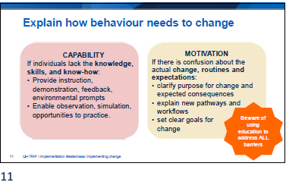

Slide | Notes
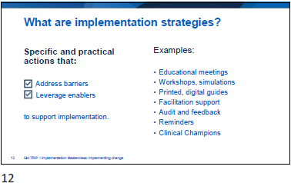

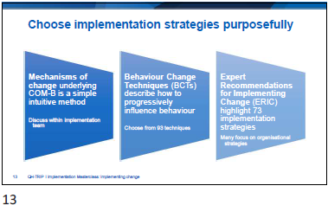

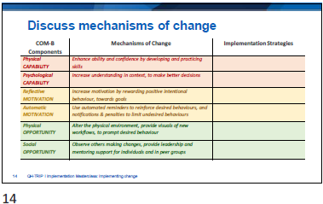

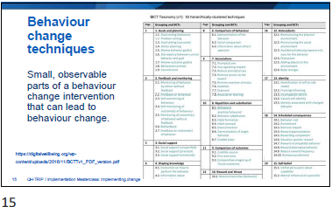

Slide | Notes
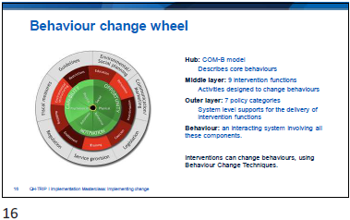

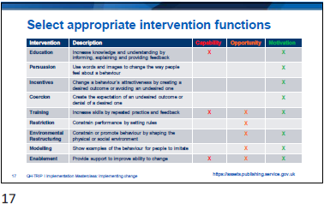

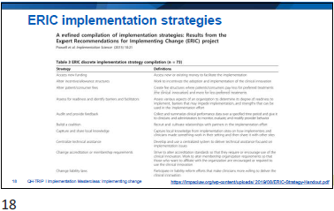

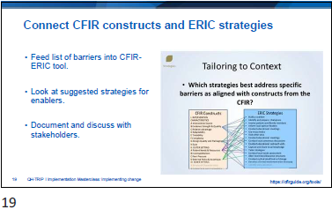

Slide | Notes
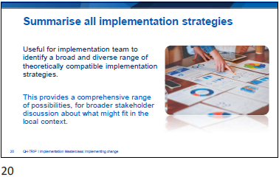

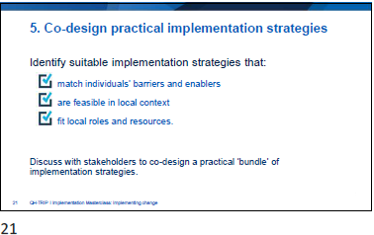

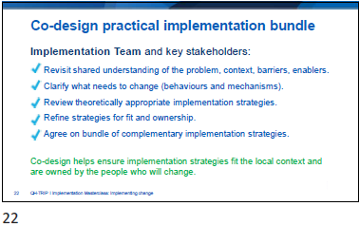

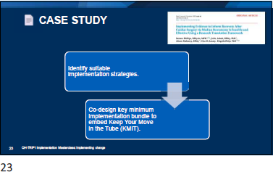

Slide | Notes
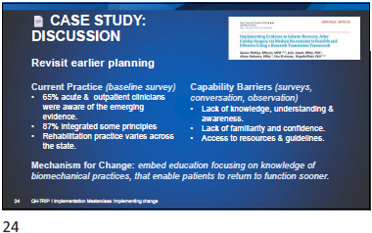

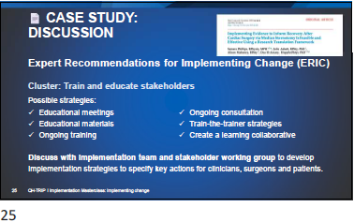

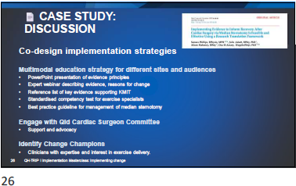

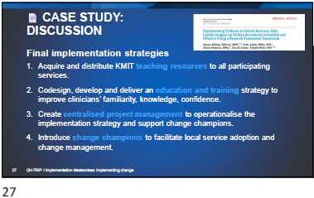

Slide | Notes
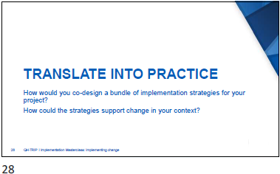

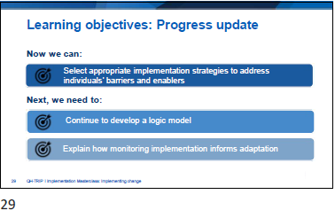

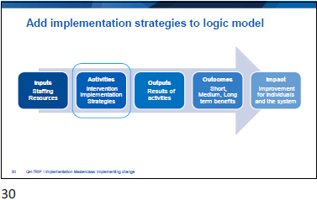

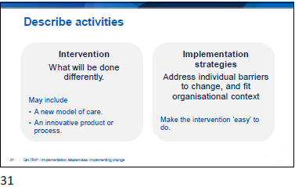

Slide | Notes
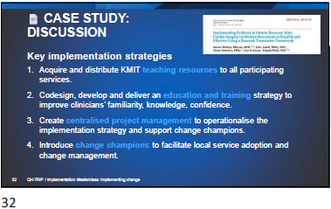

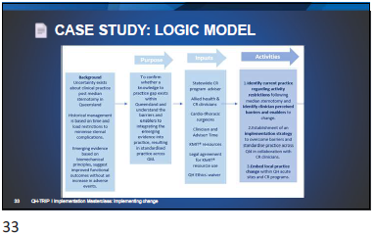

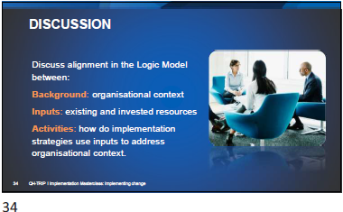

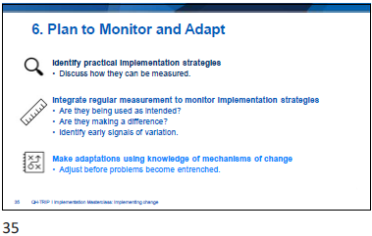

Slide | Notes
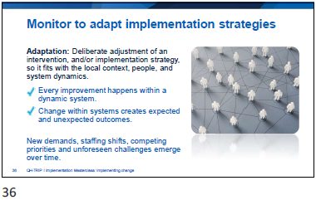

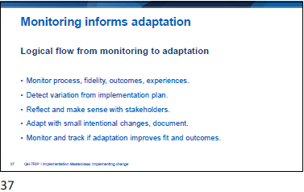

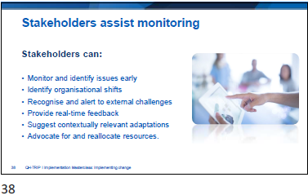

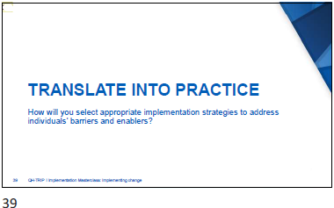

Slide | Notes
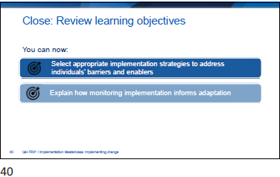

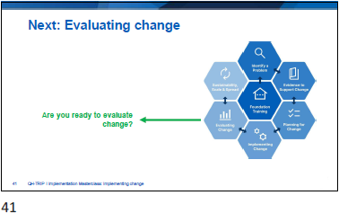

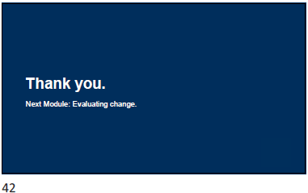



Slide | Notes
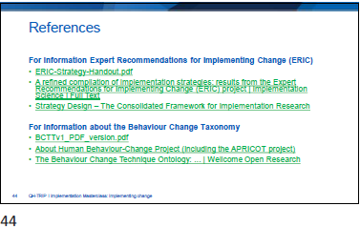

Appendix
- Reflection: Application to local practice
- Template: Sequence of Behavioural Analysis
- Template: Mechanisms of Change inform implementation strategies
- Template: Mechanisms of Change inform implementation strategies
- Template: Select appropriate intervention functions
- Template: QH-TRIP Program Logic Model

  - Reflection: Application to local context

- Where is the Problem?
- What do you want to change?
- What is the evidence for the change?
- Who is involved?
- Describe organisational context and readiness for change.
- Select implementation strategies.

  - Template: Sequence of Behavioural Analysis

- Clarify what key people need to do differently
- Identify perceived barriers and enablers to proposed change from those who need to change
- Map individual barriers and enablers to behaviour change using behavioural model (COM-B &/or TDF)
- Identify implementation strategies that fit
- Co-design practical implementation strategies
- Plan to monitor and adapt
  - Template: Mechanisms of Change inform implementation strategies
COM-B Components | Mechanisms of Change | Implementation Strategies
Physical CAPABILITY | Enhance ability and confidence by developing and practicing skills
Psychological CAPABILITY | Increase understanding in context, to make better decisions
Reflective MOTIVATION | Increase motivation by rewarding positive intentional behaviour, towards goals
Automatic MOTIVATION | Use automated reminders to reinforce desired behaviours, and notifications & penalties to limit undesired behaviours
Physical OPPORTUNITY | Alter the physical environment, provide visuals of new workflows, to prompt desired behaviour
Social OPPORTUNITY | Observe others making changes, provide leadership and mentoring support for individuals and in peer groups
  - Template: Select appropriate intervention functions
Intervention | Description | Capability | Opportunity | Motivation
Education | Increase knowledge and understanding by informing, explaining and providing feedback.
Persuasion | Use words and images to change the way people feel about a behaviour.
Incentives | Change a behaviour’s attractiveness by creating a desired outcome or avoiding an undesired one.
Coercion | Create the expectation of an undesired outcome or denial of a desired one.
Training | Increase skills by repeated practice and feedback.
Restriction | Constrain performance by setting rules.
Environmental Restructuring | Constrain or promote behaviour by shaping the physical or social environment.
Modelling | Show examples of the behaviour for people to imitate.
Enablement | Provide support to improve ability to change.

  - Template: QH-TRIP Program Logic Model
PROBLEM STATEMENT: |  |  | TRIP PROJECT NAME:
INPUTS | ACTIVITIES  Implementation Strategies | OUTPUTS  Change Activities | OUTCOMES  Short Term
INPUTS | ACTIVITIES  Implementation Strategies | OUTPUTS  Change Activities | Intermediate
INPUTS | ACTIVITIES  Implementation Strategies | OUTPUTS  Change Activities | Long Term
ASSUMPTIONS: Behaviour Change |  | EXTERNAL FACTORS: Barriers/Enablers

