QH-TRIP | Translating Research Into Practice

Implementation Masterclass
Module 4: Planning for Change - Align the organisation
Participant Handbook

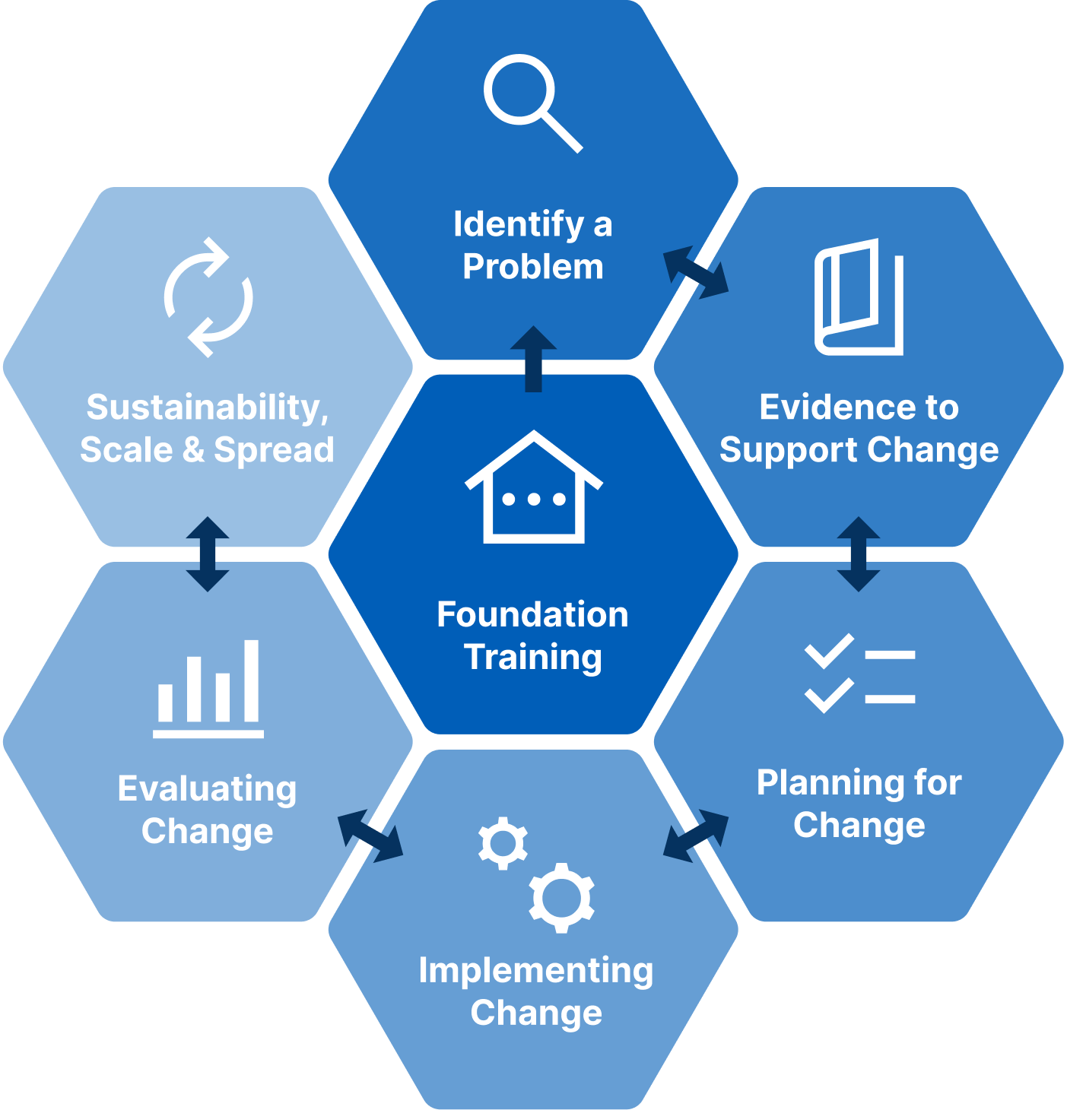

Implementation Masterclass Module 4: Planning for Change - Align the organisation Participant Handbook
Published by the State of Queensland (Queensland Health), June 2026

This document is licensed under a Creative Commons Attribution 4.0 International licence (CC BY 4.0). To view a copy of this licence, visit creativecommons.org/licenses/by/4.0/
You are free to copy, communicate and adapt the work, as long as you attribute the State of Queensland (Queensland Health).
For more information contact:
Office of the Chief Allied Health Officer (OCAHO), Health Workforce Division, Queensland Health, GPO Box 48, Brisbane QLD 4001, email allied_health_advisory@health.qld.gov.au, phone (07) 3328 9928.
Disclaimer
The content presented in this publication is distributed by the Queensland Government as an information source only. The State of Queensland makes no statements, representations or warranties about the accuracy, completeness of any information contained in this publication. The State of Queensland disclaims all responsibility and all liability (including without limitation for liability in negligence) for all expenses, losses, damages and costs you might incur as a result of the information.

Table of Contents
Prelude 4
Helpful links and resources 5
Consolidated Framework for Implementation Research (CFIR) 5
i-PARIHS 5
Context Compass Framework 5
Organisational readiness 5
Readiness tools 5
Logic models 5
Presentation slides 6
Appendix 19
A.1 Activity 1: Organisational Readiness 20
A.2 Activity 2: QH-TRIP Program Logic Model 21
A.3 Guide: QH-TRIP Program Logic Model 22
A.4 Reflection: Application to local context 23

Prelude
Welcome to Module 4 of the Implementation Masterclass.
This module continues the transition to understanding the problem in terms of its impact on people and its place within the organisation. Module 4 shifts the focus from identifying the problem and the people involved to understanding the organisational context in which change happens. In practice, stakeholder analysis and organisational context are often explored together because stakeholders understand how their service works, what supports practice, and what gets in the way. In this module, we separate these ideas to make them easier to understand and apply. The emphasis is on planning for change by understanding the organisation and its readiness to support implementation.
Behaviours are shaped by the organisations we work in, and understanding routines and culture can help participants feel more confident and capable of navigating complex health systems. In healthcare, recognising how systems, routines, expectations, and local culture influence practice can empower participants to approach change more effectively.
Using the shared case study, you will explore how organisational context, including culture, routines and structures, shapes practice and influences implementation. You will be introduced to practical ways to understand organisational context and supported in thinking more strategically about readiness for change. Reflective prompts and translation into practice activities support you to connect these ideas to your own context, building confidence and shared language that will support future conversations with peers, mentors, and researchers.
By the end of this module, you should feel more confident recognising the organisational factors that shape implementation and better equipped to plan change in a way that is realistic, respectful, and achievable.

Helpful links and resources
The following articles, blogs, videos, podcasts and websites provide useful information to support your learning. You do not need to read all resources before commencing the module.
Consolidated Framework for Implementation Research (CFIR) | Consolidated Framework For Implementation Research (cfirguide.org).
Consolidated Framework for Implementation Research (CFIR) | The Consolidated Framework for Implementation Research (CFIR) User Guide: a five-step guide for conducting implementation research using the framework (Reardon et al., 2025).
Consolidated Framework for Implementation Research (CFIR) | Using the Consolidated Framework for Implementation Research (CFIR) in implementation research and practice (Khan, 2025). The Center for Implementation.
i-PARIHS | PARIHS revisited: from heuristic to integrated framework for the successful implementation of knowledge into practice (Harvey & Kitson, 2016).
i-PARIHS | Combined use of the integrated-Promoting Action on Research Implementation in Health Services (i-PARIHS) framework with other implementation frameworks: a systematic review (Hunter et al., 2025).
i-PARIHS | Use of the i-PARIHS framework in nutrition and dietetics research and practice: A citation analysis of the literature and case studies (Young et al., 2025).
Context Compass Framework | Addressing contextual barriers in implementation: The Context Compass Framework (The Center for Implementation)
Context Compass Framework | Making context assessment manageable: how to slice and dice context in different ways (Khan & Moore, 2025). The Center for Implementation.
Organisational readiness | Organizational readiness for change: A systematic review of the healthcare literature (Caci et al., 2025).
Readiness tools | Implementation Readiness Assessment Tool (Implementation & Evaluation HUB)
Readiness tools | Readiness Thinking Tool: Why organizational readiness for change matters (Khan, 2019). The Center for Implementation.
Logic models | Developing and Using Program Logic: A Guide (NSW Health).
Logic models | Your guide to using Logic Models (NHS – Midlands and Lancashire Commissioning Support Unit).

Presentation slides
Slide | Notes
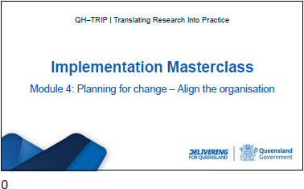

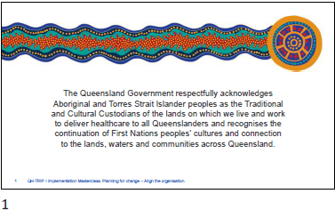

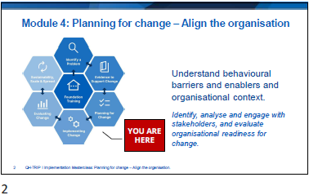

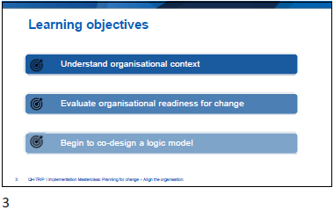

Slide | Notes
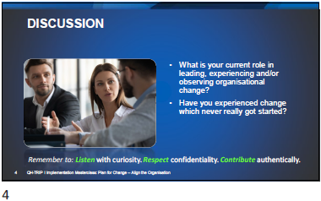

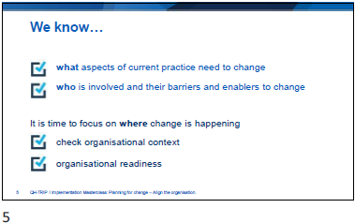

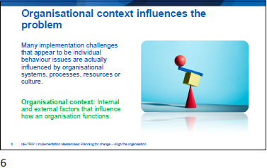

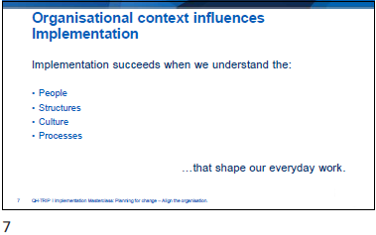

Slide | Notes
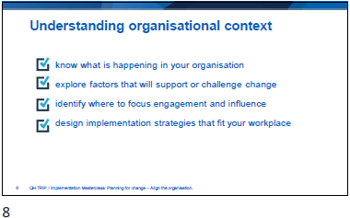

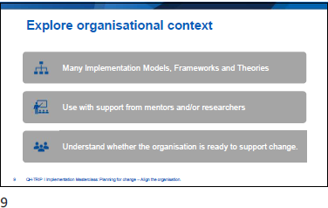

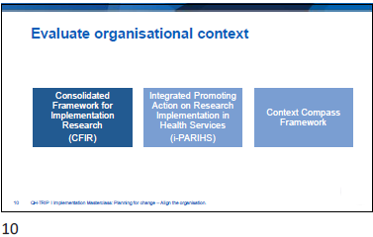

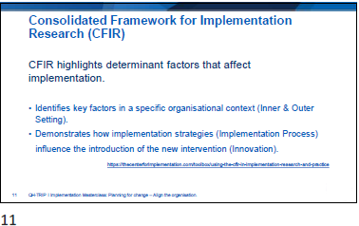

Slide | Notes
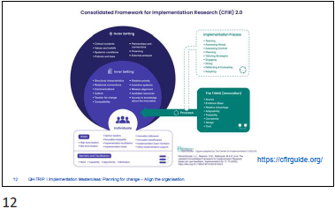

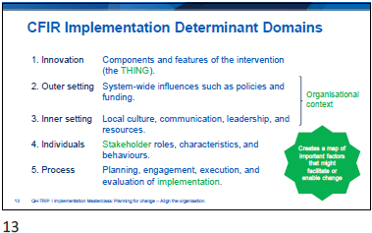

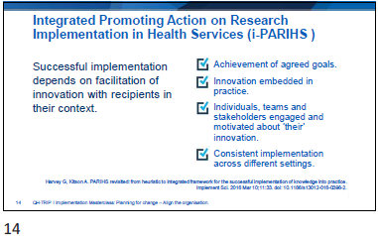

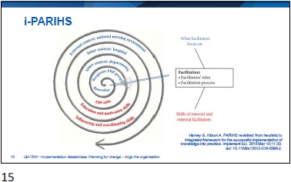

Slide | Notes
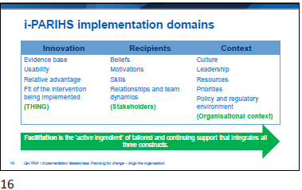

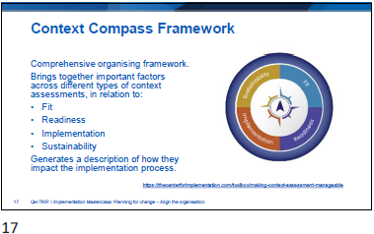

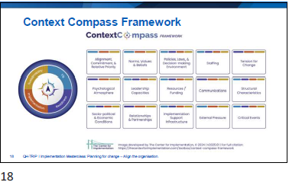

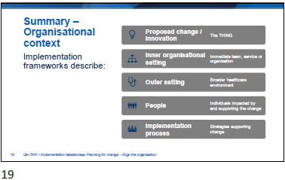

Slide | Notes
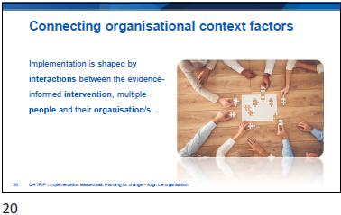

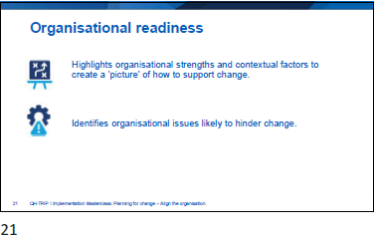

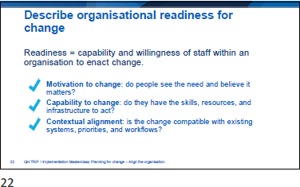

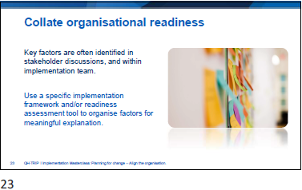

Slide | Notes
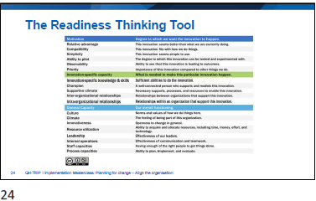

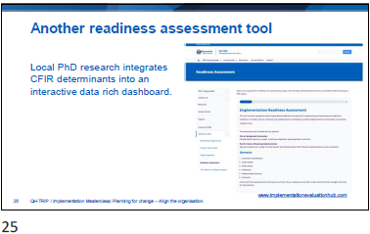

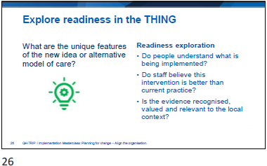

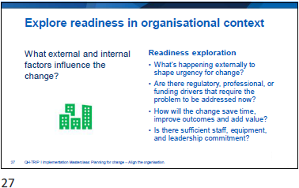

Slide | Notes
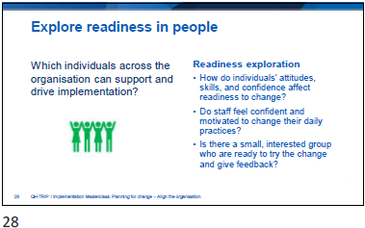

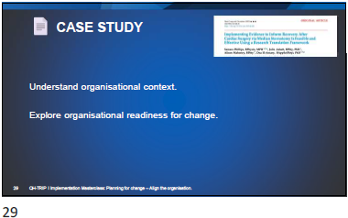

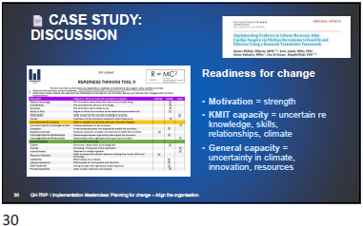

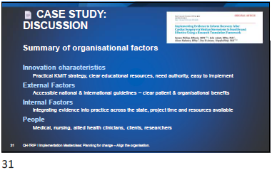

Slide | Notes
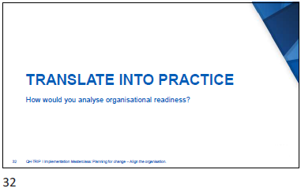
Activity 1: Organisational Readiness
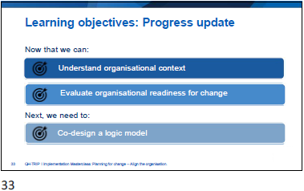

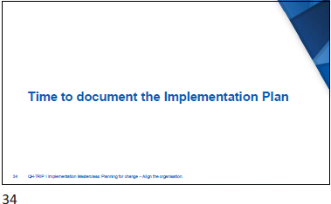

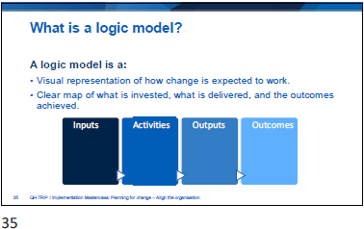

Slide | Notes
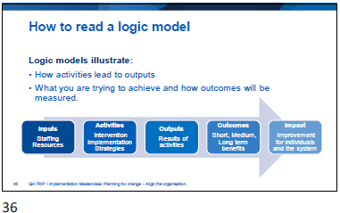

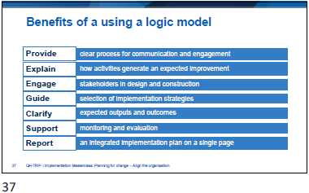

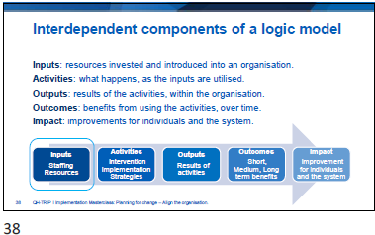

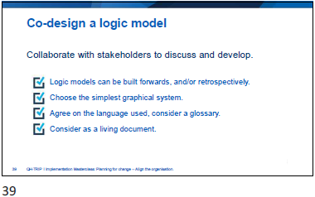

Slide | Notes
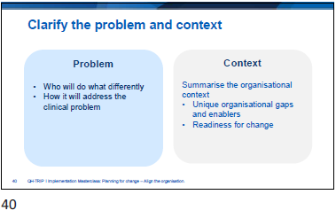

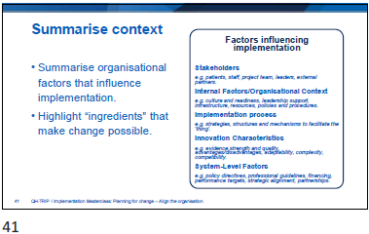

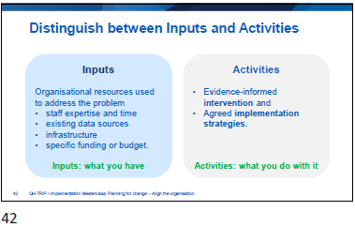

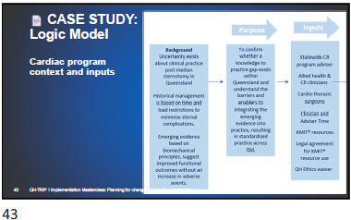

Slide | Notes
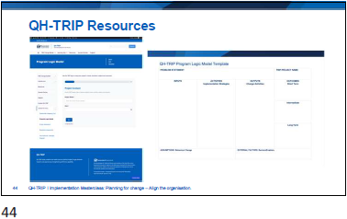

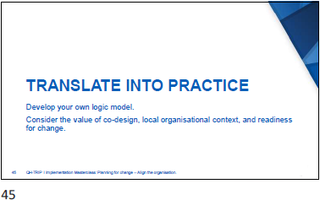
Activity 2: QH-TRIP Program Logic Model
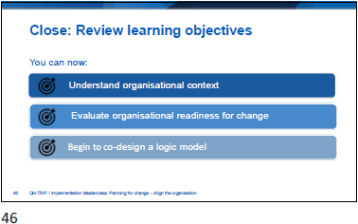

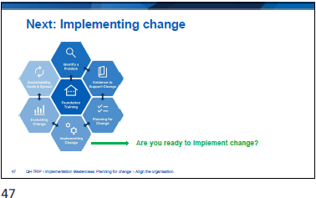

Slide | Notes
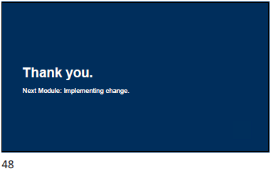

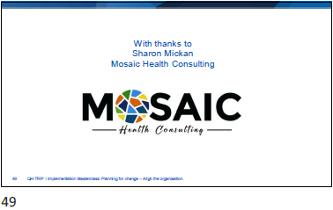

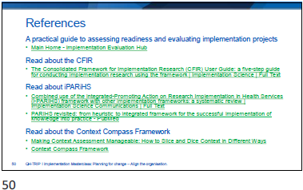

Appendix
- Activity 1: Organisational Readiness
- Activity 2: QH-TRIP Program Logic Model
- Guide: QH-TRIP Program Logic Model
- Reflection: Application to local context

  - Activity 1: Organisational Readiness
Readiness Questions |  | Local Responses
The Change  (evidence-informed model of care, innovation) | Is there clarity about what is being implemented?  Do staff believe this intervention is better than current practice?  Is it seen as evidence-informed, useful, and adaptable to local conditions?
Organisational Context  (external and internal factors) | What’s happening externally to shape urgency for change?  Are there regulatory, professional, or funding drivers that require the problem to be addressed now?  How will this save time, improve outcomes and add value?  Is there sufficient staff, equipment, and leadership commitment?
Stakeholders | How do individuals’ attitudes, skills, and confidence affect readiness to change?  Do staff feel confident and motivated to change their daily practices?  Is there a small, interested group who are ready to try the change and give feedback?

  - Activity 2: QH-TRIP Program Logic Model
PROBLEM STATEMENT: |  |  | TRIP PROJECT NAME:
INPUTS | ACTIVITIES  Implementation Strategies | OUTPUTS  Change Activities | OUTCOMES  Short Term
INPUTS | ACTIVITIES  Implementation Strategies | OUTPUTS  Change Activities | Intermediate
INPUTS | ACTIVITIES  Implementation Strategies | OUTPUTS  Change Activities | Long Term
ASSUMPTIONS: Behaviour Change |  | EXTERNAL FACTORS: Barriers/Enablers
  - Guide: QH-TRIP Program Logic Model
PROBLEM STATEMENT  Describe the evidence-practice gap this project seeks to address.  Identify why the project is needed, drawing on research evidence, local data, and stakeholder perspectives. |  |  | TRIP PROJECT NAME  What is the ‘thing’ you are implementing?
INPUTS  The things you invest in to make the project possible.  Stakeholders  e.g. patients, staff, project team, leaders, external partners.  Internal Factors/Organisational Context  e.g. culture and readiness, leadership support, infrastructure, resources, policies and procedures.  Implementation process  e.g. strategies, structures and mechanisms to facilitate the ‘thing’.  Innovation Characteristics  e.g. evidence strength and quality, advantages/disadvantages, adaptability, complexity, compatibility.  System-Level Factors  e.g. policy directives, professional guidelines, financing, performance targets, strategic alignment, partnerships. | ACTIVITIES  Implementation Strategies  The actions, strategies, or interventions you will carry out to implement the evidence into practice.  e.g. staff training, workflow redesign, stakeholder engagement, audit and feedback. | OUTPUTS  Change Activities  The specific activities you will undertake, guided by your chosen implementation strategies.  e.g. staff training sessions, handouts  Note! Movement between activities, outputs, and outcomes is dynamic, with feedback loops created through adaptation, learning, and monitoring. | OUTCOMES  Short Term  Immediate changes in knowledge, skills or awareness.
Intermediate
Changes in behaviour, policy, or service delivery.
Long Term
Ultimate impacts such as improved patient outcomes, system efficiency, or sustainability of evidence use.
ASSUMPTIONS: Behaviour Change  Conditions that must hold true for activities to lead to outcomes.  e.g. Training staff will increase their confidence to use the guidelines. |  | EXTERNAL FACTORS: Barriers/Enablers  Conditions outside the project’s control that may influence success.  e.g. organizational culture, leadership support, policy change, workforce pressures.

  - Reflection: Application to local context
- Where is the Problem?
- What do you want to change?
- What is the evidence for the change?
- Who is involved?
- Describe organisational context and readiness for change.

