QH-TRIP | Translating Research Into Practice

Implementation Masterclass
Module 3: Planning for Change - Align the people Participant Handbook
  - 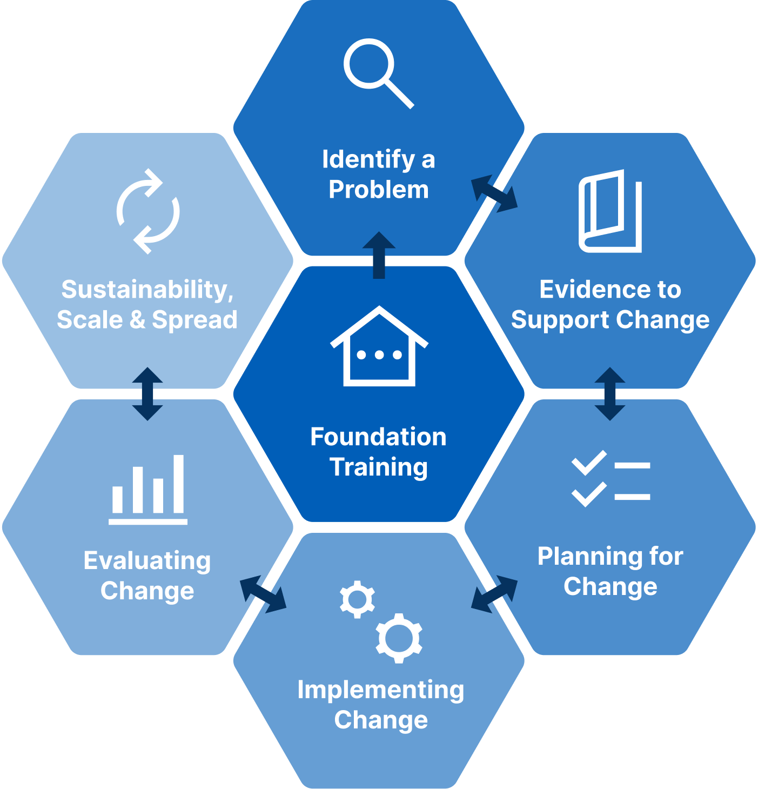

Implementation Masterclass Module 3: Planning for Change - Align the people Participant Handbook
Published by the State of Queensland (Queensland Health), June 2026

This document is licensed under a Creative Commons Attribution 4.0 International licence (CC BY 4.0). To view a copy of this licence, visit creativecommons.org/licenses/by/4.0/
You are free to copy, communicate and adapt the work, as long as you attribute the State of Queensland (Queensland Health).
For more information contact:
Office of the Chief Allied Health Officer (OCAHO), Health Workforce Division, Queensland Health, GPO Box 48, Brisbane QLD 4001, email allied_health_advisory@health.qld.gov.au, phone (07) 3328 9928.
Disclaimer
The content presented in this publication is distributed by the Queensland Government as an information source only. The State of Queensland makes no statements, representations or warranties about the accuracy, completeness of any information contained in this publication. The State of Queensland disclaims all responsibility and all liability (including without limitation for liability in negligence) for all expenses, losses, damages and costs you might incur as a result of the information.

Table of Contents
Prelude 4
Helpful links and resources 5
Stakeholder management tools 5
Power dynamics 5
Cultiv8 5
Presentation slides 6
Appendix 21
A.1 Activity 1: Stakeholder engagement summary (case study) 22
A.2 Activity 2a: Stakeholder Mapping (TRIP) 23
A.3 Activity 2b: Stakeholder Matrix (TRIP) 24
A.4 Activity 3: Identify stakeholders’ barriers/enablers and analyse barriers (case study) 25
A.5 Activity 4: Identify stakeholders’ barriers and enablers and analyse barriers (TRIP) 26
A.6 Reflection: Application to local context 27
A.7 Template: Questions to identify barriers and enablers 28
A.8 Template: Analyse stakeholders’ barriers and enablers with TDF 29

Prelude
Welcome to Module 3 of the Implementation Masterclass.
This module marks an important transition. Having clarified the problem and established a credible evidence-practice gap, the focus now shifts to planning for change by working deliberately with people.
In complex health systems, change rarely succeeds because the “right” solution has been identified. It succeeds or stalls depending on how well behavioural barriers and enablers are understood and how thoughtfully stakeholders are identified and engaged. This understanding can inspire participants to see their role as crucial in shaping successful change, fostering a sense of purpose.
Using the shared case study, participants will explore how behavioural influences shape everyday practice and how different stakeholder groups experience, enable, or constrain change. This approach aims to spark curiosity and make participants feel more connected to real-world applications, encouraging active participation.
Throughout this module, you will be encouraged to:
- Look beyond specific improvements to the behavioural dynamics that influence practice.
- Remain curious about the factors that shape behaviour and opportunities for change.
- Consider different perspectives on what maintains current ways of working.
- Recognise that resistance to change is rarely explained by motivation alone.
You may draw on your own experiences of past change initiatives in this module. Use the reflections to deepen your understanding of implementation and connect concepts from the case study to your own context.
By the end of this module, you should have a clearer understanding of why aligning people matters, how behavioural barriers and enablers influence change, and why early stakeholder engagement provides a strong foundation for effective implementation in later modules.

Helpful links and resources
The following articles, blogs, videos, podcasts and websites provide useful information to support your learning. You do not need to read all resources before commencing the module.
Stakeholder management tools | Achieving stakeholder management success with the Power-Interest grid (Malinawan, 2024). Rosemet.
Stakeholder management tools | The Power-Interest grid: a tool for stakeholder identification and management (2024). Rigcert Education.
Stakeholder management tools | Power vs. interest: Master the stakeholder matrix for success. Change Adaptive.
Power dynamics | Balancing acts: Tackling power dynamics in implementation (Kennedy, 2024). National Implementation Research Network.
Cultiv8 | Cultiv8 tool (The Center for Implementation).
COM-B | COM-B.org
COM-B | Why are there different versions of the COM-B Model diagram? (West & Michie, 2023).
COM-B | Susan Michie on Behavioural Change (2020). Social Science Space.
COM-B | A guide on the COM-B Model of Behaviour (Social Change UK).
Theoretical Domains Framework (TDF) | What Is the Theoretical Domains Framework (TDF)? (Moore, 2025). The Center for Implementation.
Theoretical Domains Framework (TDF) | A guide to using the Theoretical Domains Framework of behaviour change to investigate implementation problems (Atkins et al., 2017).

Presentation slides
Slide | Notes
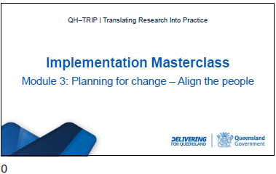

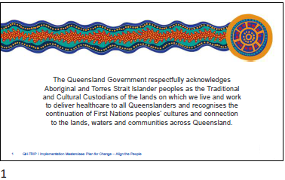

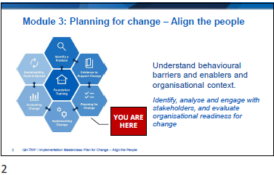

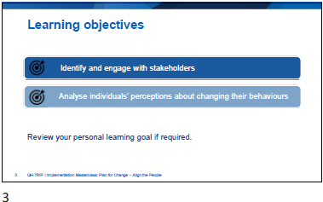

Slide | Notes
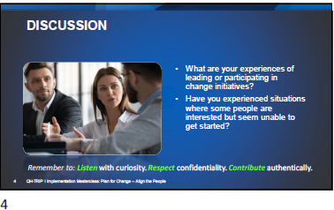

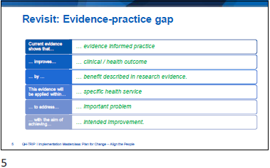

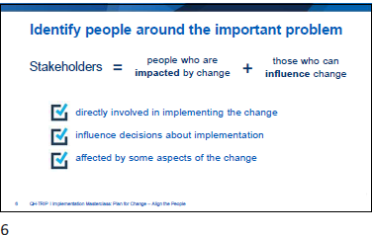

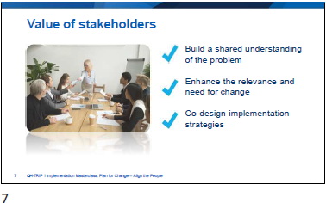

Slide | Notes
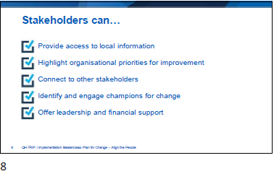

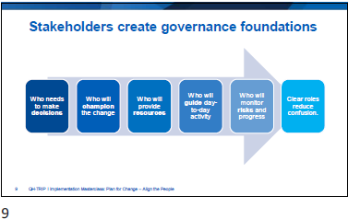

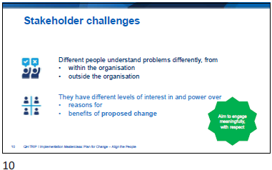

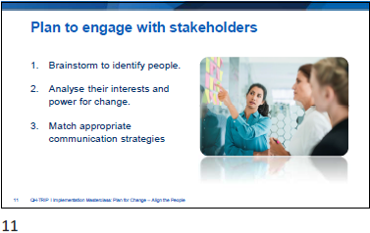

Slide | Notes
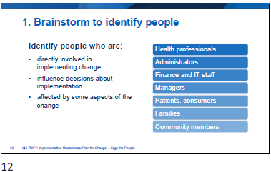

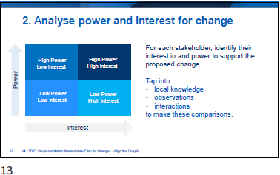

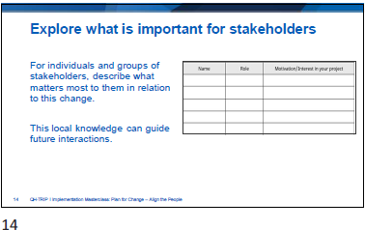

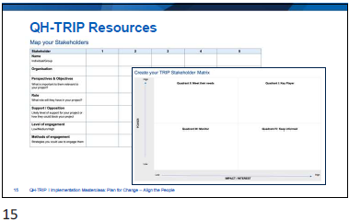

Slide | Notes
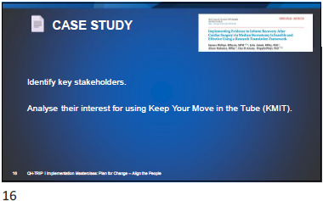
Activity 1: Stakeholder engagement summary (case study)
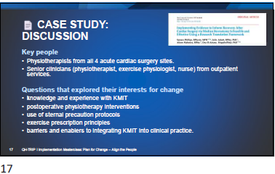

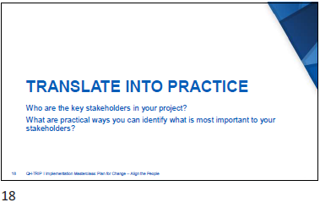
Activity 2a: Stakeholder Mapping (TRIP)
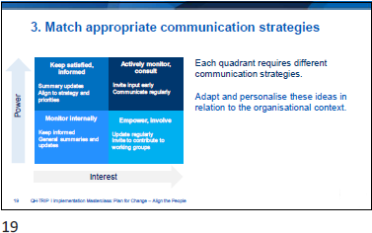
Activity 2b: Stakeholder Matrix (TRIP)

Slide | Notes
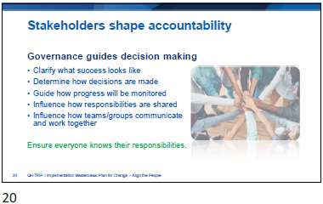

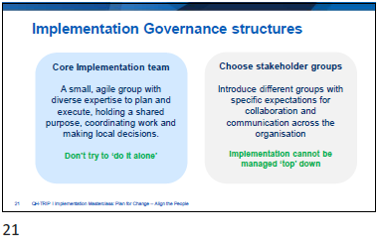

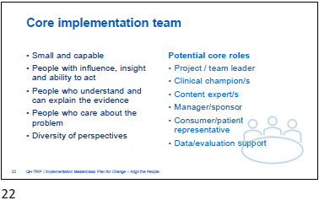

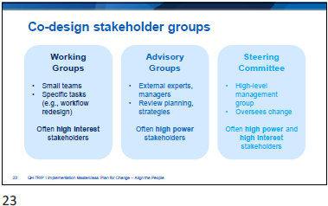

Slide | Notes
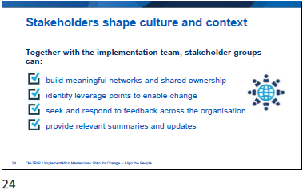

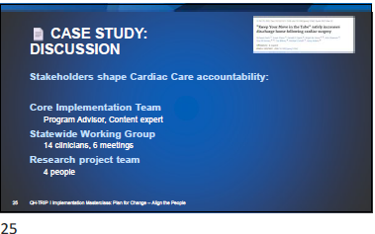

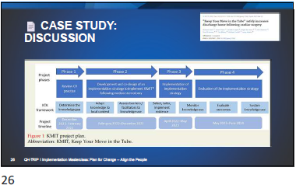

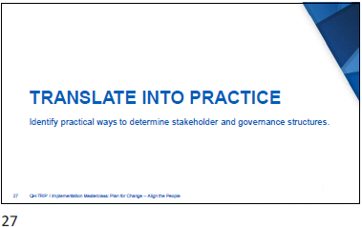

Slide | Notes
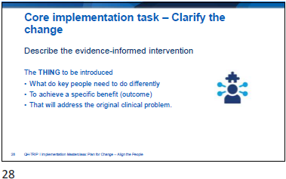

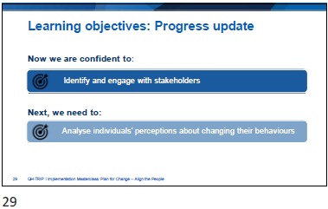

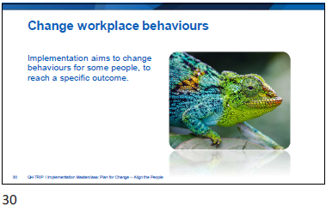

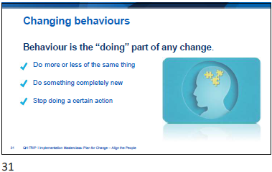

Slide | Notes
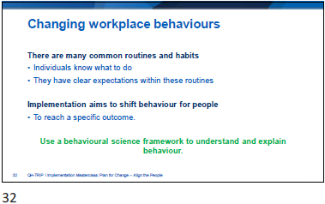

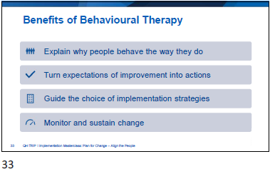

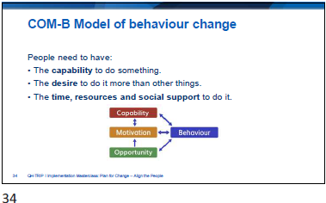

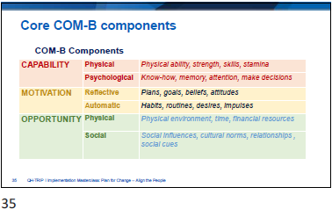

Slide | Notes
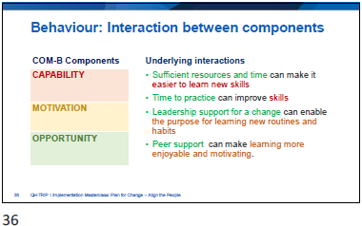

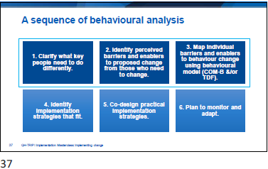

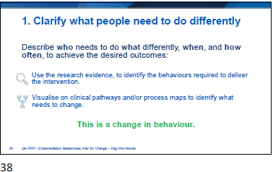

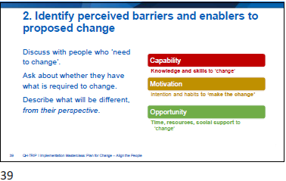
Activity 3: Identify stakeholders’ barriers/enablers and analyse barriers (case study)

Slide | Notes
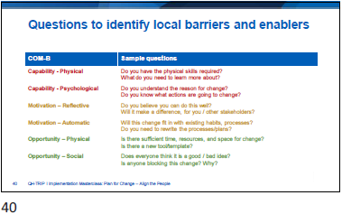

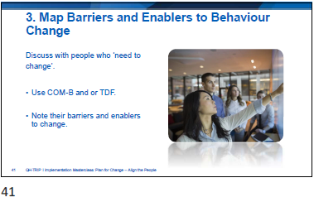

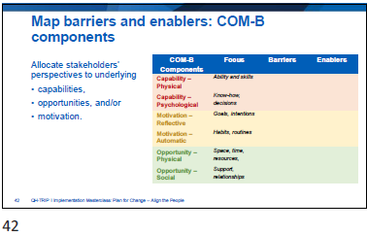

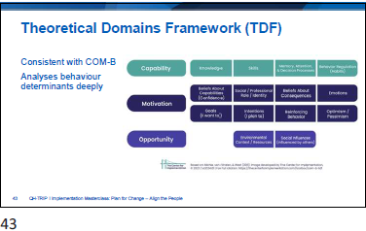

Slide | Notes
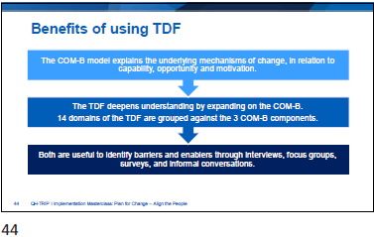

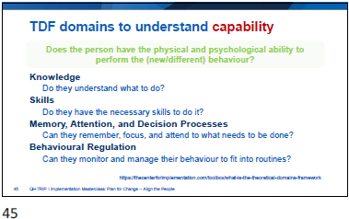

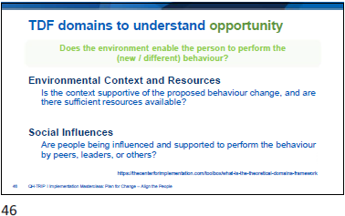

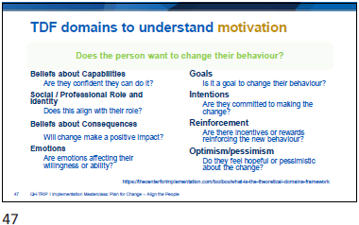

Slide | Notes
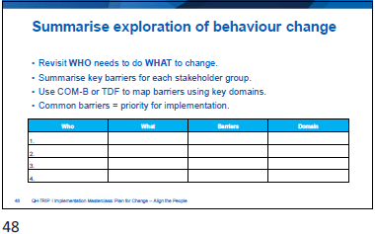

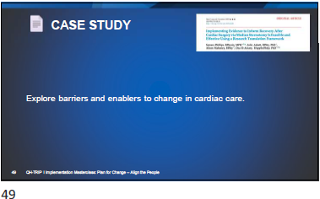

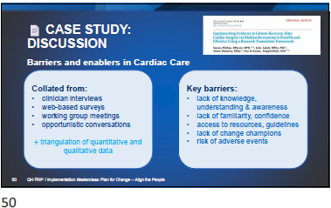

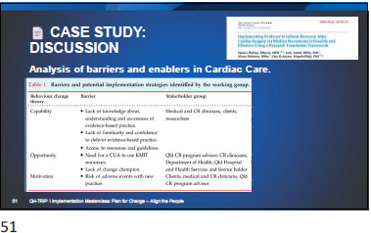

Slide | Notes
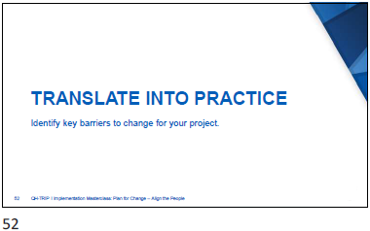
Activity 4: Identify stakeholders’ barriers and enablers and analyse barriers (TRIP)
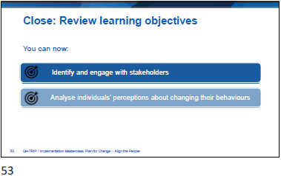

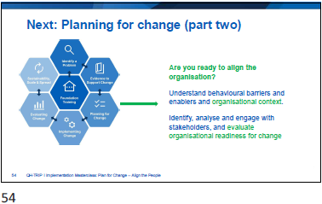

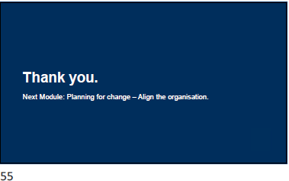

Slide | Notes


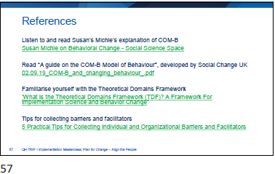

Appendix
- Activity 1: Stakeholder engagement summary (case study)
- Activity 2a: Map your stakeholders (TRIP)
- Activity 2b: Stakeholder engagement summary (TRIP)
- Activity 3: Identify stakeholders’ barriers/enablers and analyse barriers (case study)
- Activity 4: Identify stakeholders’ barriers/enablers and analyse barriers (TRIP)
- Reflection: Application to local context
- Template: Questions to identify barriers and enablers
- Template: Analyse stakeholders’ barriers and enablers with TDF

  - Activity 1: Stakeholder engagement summary (case study)

Communication strategy:  Actively monitor and consult  Invite input early, communicate regularly | HIGH POWER  HIGH INTEREST | LOW POWER  HIGH INTEREST | Communication strategy:  Empower, involve, inform  Update regularly and invite to contribute to working groups
Stakeholders: |  | Stakeholders:
Communication strategy:  Keep satisfied and informed  Provide summary updates aligned with strategic priorities | HIGH POWER  LOW INTEREST | LOW POWER  LOW INTEREST | Communication strategy:  Monitor with minimal effort  Keep informed with general summaries and updates
Stakeholders: |  | Stakeholders:
Write your local stakeholder communications here

  - Activity 2a: Stakeholder Mapping (TRIP)
Stakeholder | 1 | 2 | 3 | 4 | 5
Name
Individual/Group
Organisation
Perspectives & Objectives
What is important to them relevant to your project?
Role
What role will they have in your project?
Support / Opposition
Likely level of support for your project or how they could block your project
Level of engagement
Low/Medium/High
Methods of engagement
Strategies you could use to engage them

  - Activity 2b: Stakeholder Matrix (TRIP)

Communication strategy:  Actively monitor and consult  Invite input early, communicate regularly | HIGH POWER  HIGH INTEREST | LOW POWER  HIGH INTEREST | Communication strategy:  Empower, involve, inform  Update regularly and invite to contribute to working groups
Local stakeholders: |  | Local stakeholders:
Communication strategy:  Keep satisfied and informed  Provide summary updates aligned with strategic priorities | HIGH POWER  LOW INTEREST | LOW POWER  LOW INTEREST | Communication strategy:  Monitor with minimal effort  Keep informed with general summaries and updates
Local stakeholders: |  | Local stakeholders:

  - Activity 3: Identify stakeholders’ barriers/enablers and analyse barriers (case study)

COM-B Components | Collective Perspective | Barriers/Enablers | Domain (interpretation)
Physical  Capability | Ability and skills
Psychological  Capability | Know-how, decisions
Reflective  Motivation | Goals, intentions
Automatic  Motivation | Habits, routines
Physical  Opportunity | Space, resources, time
Social  Opportunity | Support, relationships

  - Activity 4: Identify stakeholders’ barriers and enablers and analyse barriers (TRIP)

COM-B Components | Collective Perspective | Barriers/Enablers | Domain (interpretation)
Physical  Capability | Ability and skills
Psychological  Capability | Know-how, decisions
Reflective  Motivation | Goals, intentions
Automatic  Motivation | Habits, routines
Physical  Opportunity | Space, resources, time
Social  Opportunity | Support, relationships

  - Reflection: Application to local context

- Where is the Problem?
- What do you want to change?
- What is the evidence for the change?
4. Who is involved?

  - Template: Questions to identify barriers and enablers

COM-B | Sample questions | Local questions
Physical  Capability | Do you have the physical skills required?  What do you need to learn more about?
Psychological  Capability | Do you understand the reason for change?  Do you know what actions are going to change?
Reflective  Motivation | Do you believe you can do this well?  Will it make a difference, for you/your patients?
Automatic  Motivation | Will this change fit in with existing habits, processes?  Do you need to rewrite the processes/plans?
Physical  Opportunity | Are there sufficient time, resources and space for change?  Is there a new tool/template?
Social  Opportunity | Does everyone think it is a good/bad idea?  Who is blocking this change? Why?

  - Template: Analyse stakeholders’ barriers and enablers with TDF
COM-B | Theoretical Domains | Description | Interpretation
Capability | Knowledge | Do they understand what to do?
Capability | Skills | Do they have the necessary skills to do it?
Capability | Memory, Attention, Decision Processes | Can they remember, focus and pay attention to what needs to be done?
Capability | Behavioural Regulation | Can they monitor and manage their behaviour to fit into routines?
Motivation | Beliefs about Capabilities | Are they confident they can do it?
Motivation | Social/Professional Role and Identity | Does this align with their role?
Motivation | Beliefs about Consequences | Will change make a positive impact?
Motivation | Emotions | Are emotions affecting their willingness or ability?
Motivation | Goals | Is it a goal to change their behaviour?
Motivation | Intentions | Are they committed to making the change?
Motivation | Reinforcement | Are there incentives or rewards to reinforce the new behaviour?
Motivation | Optimism/pessimism | Do they feel hopeful or pessimistic about the change?
Opportunity | Environmental Context and Resources | Is the context supportive of the proposed behaviour change, and are there sufficient resources available?
Opportunity | Social Influences | Are people being influenced and supported to perform the behaviour by peers, leaders, or others?

