QH-TRIP | Translating Research Into Practice

Implementation Masterclass
Module 2: Evidence to Support Change
Participant Handbook
  - 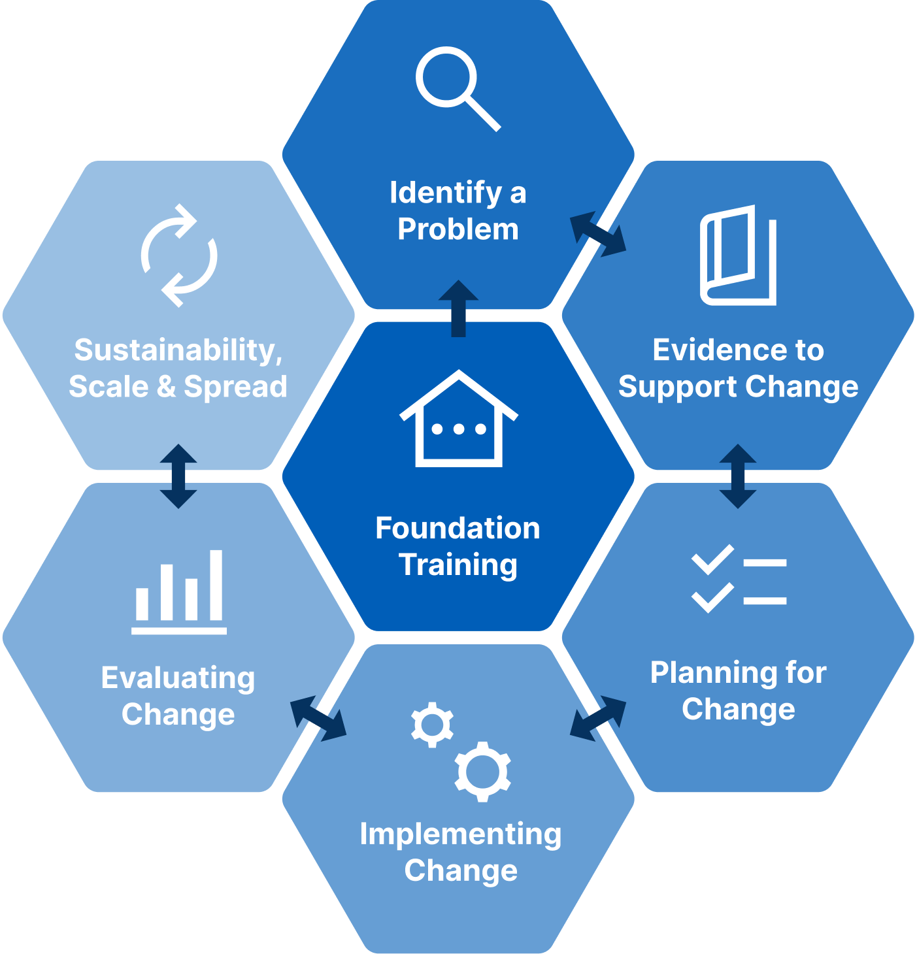

Implementation Masterclass Module 2: Evidence to Support Change Participant Handbook
Published by the State of Queensland (Queensland Health), June 2026

This document is licensed under a Creative Commons Attribution 4.0 International licence (CC BY 4.0). To view a copy of this licence, visit creativecommons.org/licenses/by/4.0/
You are free to copy, communicate and adapt the work, as long as you attribute the State of Queensland (Queensland Health).
For more information contact:
Office of the Chief Allied Health Officer (OCAHO), Health Workforce Division, Queensland Health, GPO Box 48, Brisbane QLD 4001, email allied_health_advisory@health.qld.gov.au, phone (07) 3328 9928.
Disclaimer
The content presented in this publication is distributed by the Queensland Government as an information source only. The State of Queensland makes no statements, representations or warranties about the accuracy, completeness of any information contained in this publication. The State of Queensland disclaims all responsibility and all liability (including without limitation for liability in negligence) for all expenses, losses, damages and costs you might incur as a result of the information.

Table of Contents
Prelude 4
Helpful links and resources 5
Presentation slides 6
Appendix 17
A.1 Activity 1: Interpret research evidence for improvement (case study) 18
A.2 Activity 2: Identify and communicate the research evidence (TRIP) 19
A.3 Activity 3: Collate different types of evidence (case study) 20
A.4 Activity 4: Collate different types of evidence (TRIP) 21
A.5 Activity 5: Summarise the evidence-practice gap (case study) 22
A.6 Activity 6: Summarise the evidence-practice gap (TRIP) 23
A.7 Reflection: Application to local context 24

Prelude
Welcome to the second module of the Implementation Masterclass.
In this module, the focus shifts to working with evidence in a practical and purposeful way.
Many improvement efforts begin with a strong sense that “something needs to change,” but often move too quickly to solutions without fully confirming the problem or understanding what the evidence tells us. This module is designed to help you pause, clarify, and build confidence that the issue you are concerned about is real, addressable, and worthy of implementation effort.
You will explore how different types of evidence, including research findings, operational data, and patient insights, can be used together to create a clear picture of a problem. The aim is to develop skills in summarising evidence in ways that support implementation planning in everyday health settings.
Using a case study, you will see how evidence can be used to:
- Confirm that a clinical problem is addressable.
- Describe what good practice looks like.
- Identify where current practice differs from the evidence.
A key outcome of this module is learning how to articulate your evidence–practice gap: a clear description of what is happening now, what the evidence suggests should be happening, and why that difference matters. Establishing this gap provides a strong foundation for engaging stakeholders, selecting implementation strategies, and planning for change in later modules.
The reflections in this module invite you to practise summarising evidence and recognising gaps within your own context, building skills and language that you can carry forward into future conversations with peers, mentors, and researchers. Activities will support you to apply this work immediately to your project.

Helpful links and resources
The following articles, blogs, videos, podcasts and websites provide useful information to support your learning. You do not need to read all resources before commencing the module.
CASP  (free and downloadable guides to critically appraise different study designs) | CASP – Critical Appraisal Skills Programme
TREAT Journal Club  (a practical way to learn how to critically appraise relevant research) | TREAT Journal Clubs
Case study key article  (read the methods section for details of data collection – Phase 1: Review of CR Practice) | Implementing evidence to inform recovery after cardiac surgery via median sternotomy is feasible and effective using a research translation framework. (Phillips et al., 2025).
Keep Your Move in the Tube – videos | Keep Your Move in the Tube. (Sarasota Memorial Health Care System).
Keep Your Move in the Tube – videos | Keep your ‘Move in the Tube’ During Heart Rehab. (KSAT 12).
Keep Your Move in the Tube – videos | 2022 Gage Award Winner | Memorial Healthcare System – Keep Your Move in the Tube (America’s Essential Hospitals).
Keep Your Move in the Tube – background evidence | “Keep Your Move in the Tube” safely increases discharge home following cardiac surgery. (Gach et al., 2021).
Keep Your Move in the Tube – background evidence | Evidence-based strategies for movement after sternotomy. (Danielsen & Lie, 2024).

Presentation slides
Slide | Notes
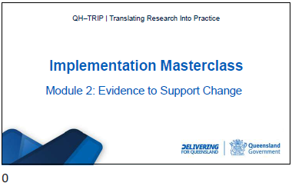

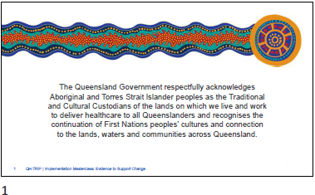

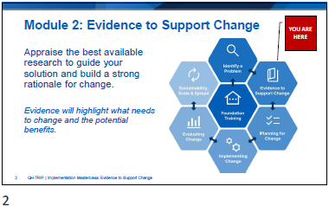

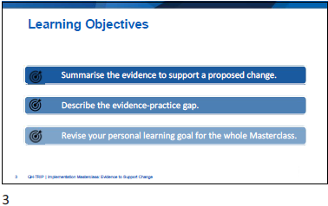

Slide | Notes
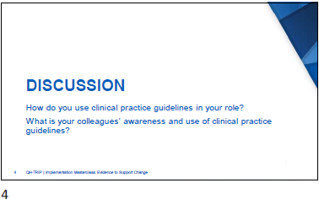

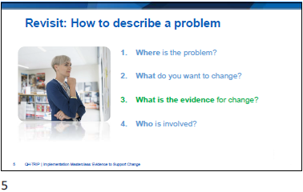

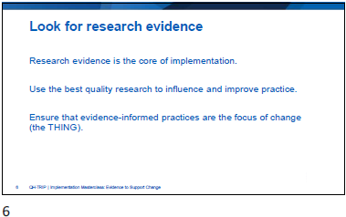

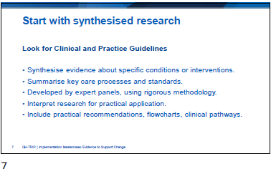

Slide | Notes
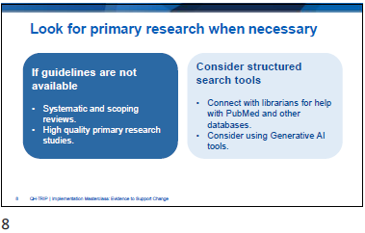

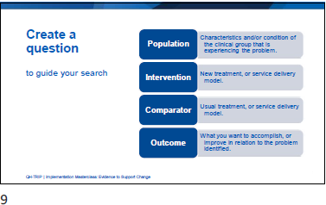

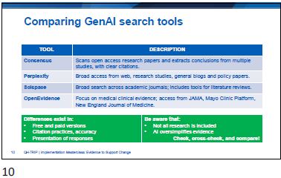

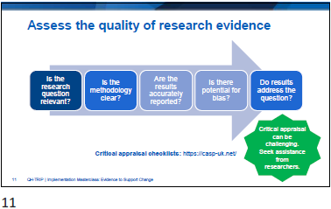

Slide | Notes
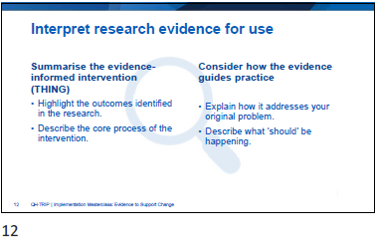

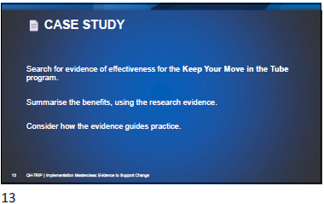
Activity 1: Interpret research evidence for improvement (case study)
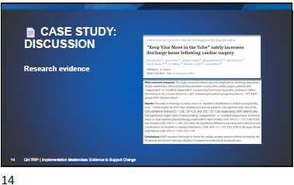

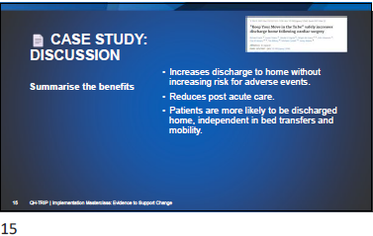

Slide | Notes
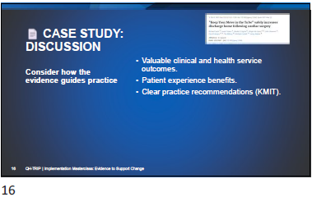

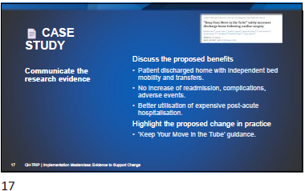

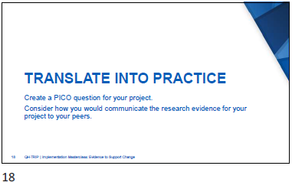
Activity 2: Identify and communicate the research evidence (TRIP)
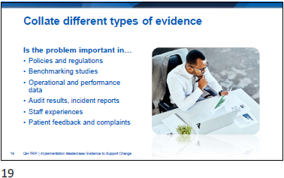

Slide | Notes
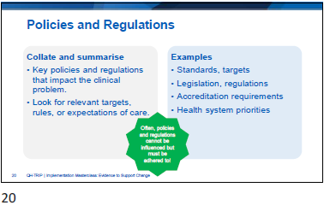

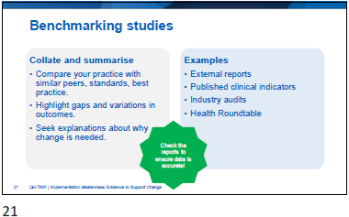

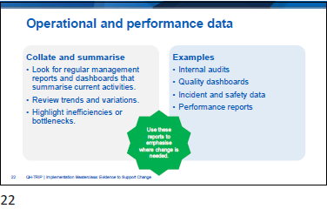

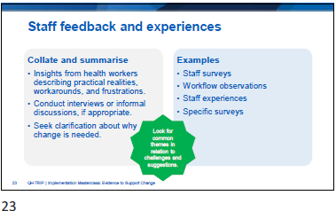

Slide | Notes
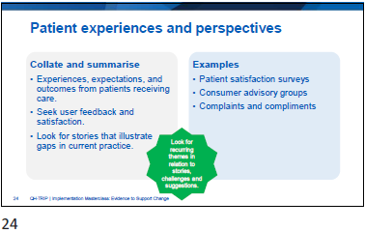

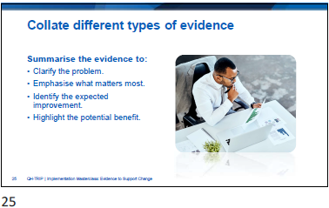

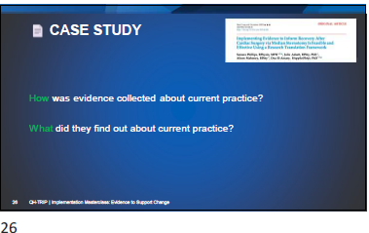
Activity 3: Collate different types of evidence (case study)
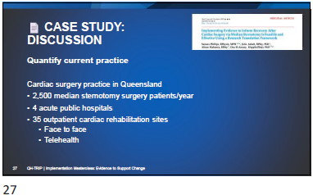

Slide | Notes
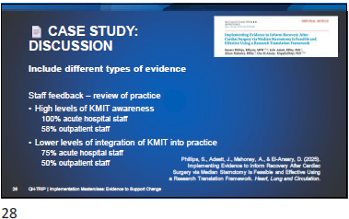

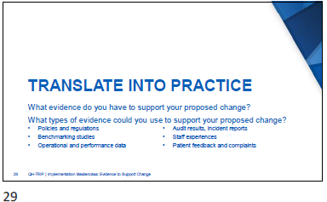
Activity 4: Collate different types of evidence (TRIP)
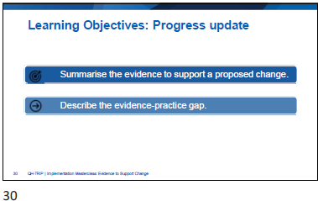

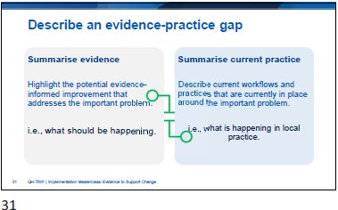

Slide | Notes
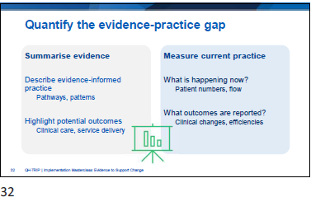

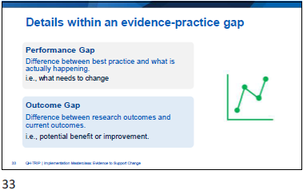

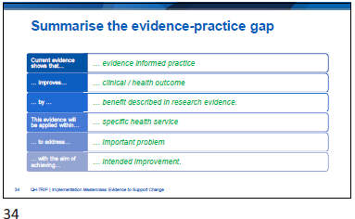

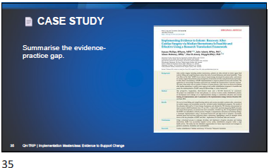
Activity 5: Summarise the evidence-practice gap (case study)

Slide | Notes
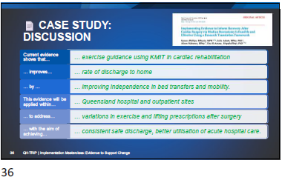

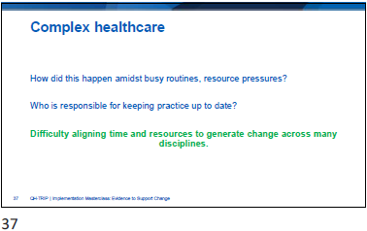

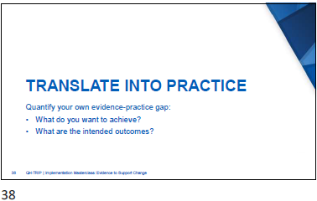
Activity 6: Summarise the evidence-practice gap (TRIP)
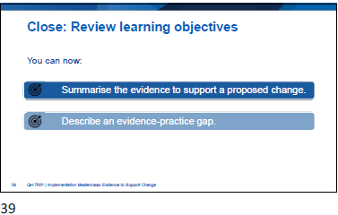

Slide | Notes
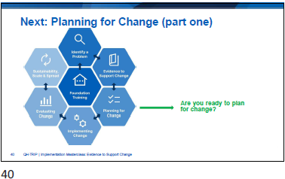

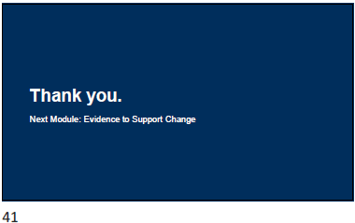

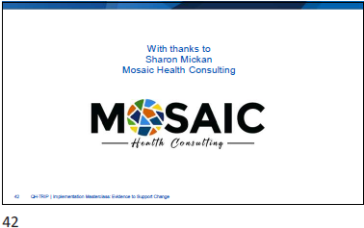

Appendix
- Activity 1: Interpret research evidence for improvement (case study).
- Activity 2: Identify and communicate the research evidence (TRIP).
- Activity 3: Collate different types of evidence (case study).
- Activity 4: Collate different types of evidence (TRIP).
- Activity 5: Summarise the evidence-practice gap (case study).
- Activity 6: Summarise the evidence-practice gap (TRIP).
- Reflection: Application to local context.

  - Activity 1: Interpret research evidence for improvement (case study)

Create a question to guide your search
P:
I:
C:
O:
Identify the research evidence
Summarise the benefits from the research
How does the evidence guide practice?
  - Activity 2: Identify and communicate the research evidence (TRIP)
Create a question to guide your search
P:
I:
C:
O:
Identify the research evidence
What is the proposed change in practice?
What are the proposed benefits from the research?
How does the evidence guide practice?

  - Activity 3: Collate different types of evidence (case study)

Sources of Evidence | Notes and Reflections
Interpret and summarise the research evidence.
Is the problem influenced by Policy and Regulatory requirements?
Is it consistent with organisational goals and expectations?
Is there evidence of the problem in comparative or benchmarking data?
Have staff experienced frustration around this problem?
Have patients or consumers provided feedback or complaints about the problem?

  - Activity 4: Collate different types of evidence (TRIP)

Sources of Evidence | Notes and Reflections
Interpret and summarise the research evidence.
Is the problem influenced by Policy and Regulatory requirements?
Is it consistent with organisational goals and expectations?
Is there evidence of the problem in comparative or benchmarking data?
Have staff experienced frustration around this problem?
Have patients or consumers provided feedback or complaints about the problem?

  - Activity 5: Summarise the evidence-practice gap (case study)

Current evidence shows that …. | evidence-informed practice
improves …. | clinical/health outcome
by …. | benefit described in research evidence
This evidence will be applied within …. | specific health service
to address …… | important problem
with the aim of achieving….. | intended improvement
  - Activity 6: Summarise the evidence-practice gap (TRIP)

Current evidence shows that …. | evidence-informed practice
improves …. | clinical/health outcome
by …. | benefit described in research evidence
This evidence will be applied within …. | specific health service
to address …… | important problem
with the aim of achieving….. | intended improvement
  - Reflection: Application to local context

- Where is the Problem?
- What do you want to change?
- What is the evidence for the change?
4. Who is involved?

