QH-TRIP | Translating Research Into Practice

Implementation Masterclass
Module 1: Identify a Problem
Participant Handbook
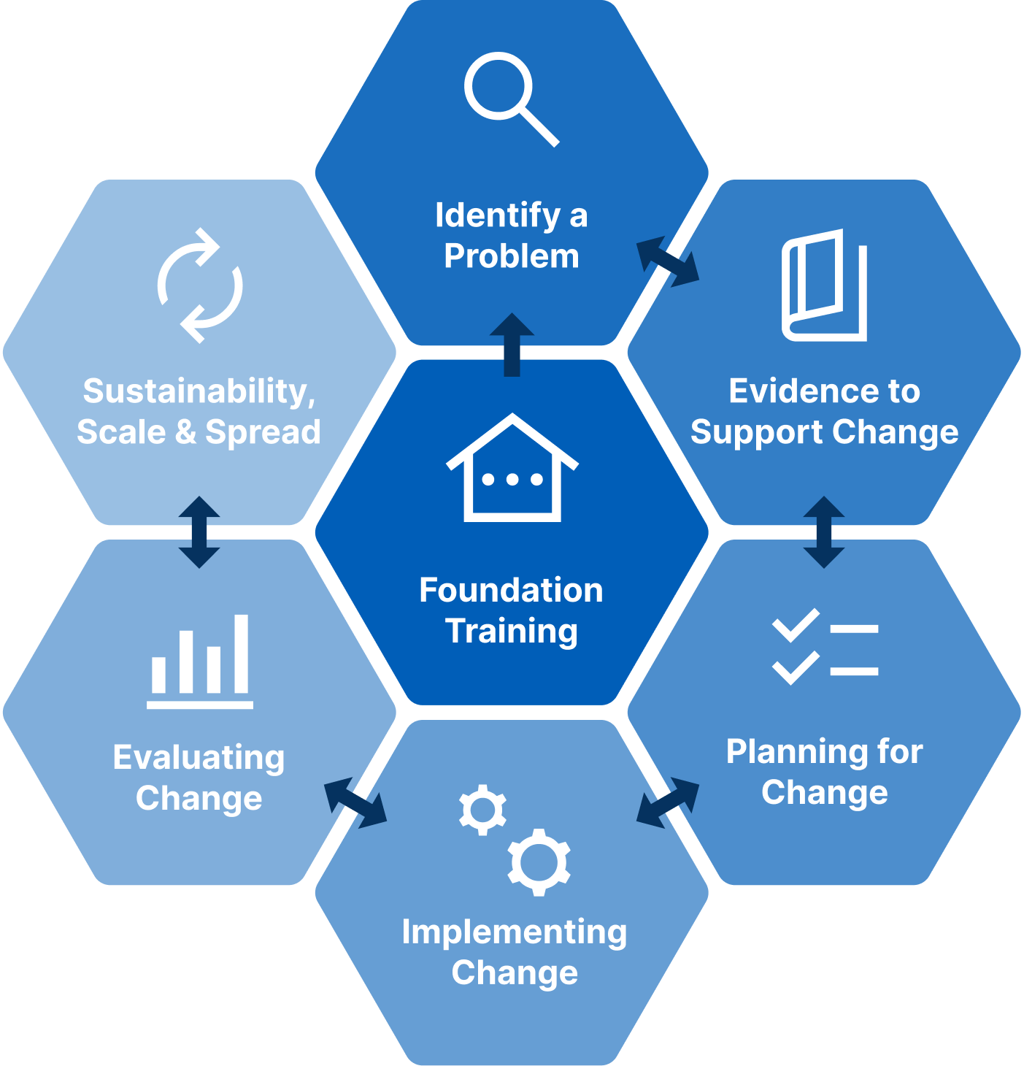

Implementation Masterclass Module 1: Identify a Problem Participant Handbook
Published by the State of Queensland (Queensland Health), June 2026

This document is licensed under a Creative Commons Attribution 4.0 International licence (CC BY 4.0). To view a copy of this licence, visit creativecommons.org/licenses/by/4.0/
You are free to copy, communicate and adapt the work, as long as you attribute the State of Queensland (Queensland Health).
For more information contact:
Office of the Chief Allied Health Officer (OCAHO), Health Workforce Division, Queensland Health, GPO Box 48, Brisbane QLD 4001, email allied_health_advisory@health.qld.gov.au, phone (07) 3328 9928.
Disclaimer
The content presented in this publication is distributed by the Queensland Government as an information source only. The State of Queensland makes no statements, representations or warranties about the accuracy, completeness of any information contained in this publication. The State of Queensland disclaims all responsibility and all liability (including without limitation for liability in negligence) for all expenses, losses, damages and costs you might incur as a result of the information.

Table of Contents
Prelude 4
Helpful links and resources 5
Implementation 5
Presentation slides 6
Appendix 21
A.1 Template: My personal learning goal 22
A.2 Activity 1: Describe the problem (case study) 23
A.3 Activity 2: Describe the problem (TRIP) 24
A.4 Activity 3: Discuss the importance of the problem 24
A.5 Activity 4: Reflection – Describe your own clinical problem 25
A.6 QH-TRIP Decision Tree: Identify a Problem 27

Prelude
Welcome to the Implementation Masterclass. It’s great to have you here.
You may have recently completed the Implementation Foundations workshop, or you may be returning to implementation after some time away from formal learning. Wherever you are starting from, this Masterclass series is designed to build your confidence, deepen your understanding, and strengthen your capability to work with implementation in real-world health settings.
Across the seven Implementation Masterclass modules, you will revisit familiar concepts and explore new ways of thinking about implementation, with greater structure, practical tools, and opportunities to consider how implementation decisions are made in practice. The Masterclass moves beyond what implementation is to focus on how implementation unfolds within complex health systems.
A single case study is used throughout the Masterclass to bring implementation decisions to life. You will explore how choices were made in a local health service, why particular strategies were selected, and how plans were adapted along the way. You are also invited to bring your own project to this workshop to apply your learnings to your own practice in a safe and supported learning environment. Finally, each module also includes reflective prompts to help you connect the content to your own context. Over time, these reflections are intended to build your confidence to engage more actively with mentors, researchers, and peers in future implementation and improvement work.
This Masterclass is an invitation to think more clearly about change, work with complexity rather than around it, and recognise implementation as a skill that can be developed, strengthened, and shared. We encourage you to stay curious, reflect openly, and enjoy the learning journey ahead.

Helpful links and resources
The following articles, blogs, videos, podcasts and websites provide useful information to support your learning. You do not need to read all resources before commencing the module.
Implementation | Implementation science: What is it and why should I care? (Bauer & Kirchner, 2019).
Implementation | An introduction to implementation science for the non-specialist. (Bauer et al., 2015).
Implementation | Implementation science: A critical but undervalued part of the healthcare innovation ecosystem. (Chan et al., 2022).
Implementation | Implementation science made too simple: a teaching tool. (Curran, 2020).
Implementation | Concept analysis of health research translation nomenclature. (Lizarondo et al., 2025).
Implementation | What can implementation science do for you? Key success stories from the field. (Kilbourne, Glasgow, & Chambers, 2020).
Implementation – podcast | An implementation scientist and clinical nurse specialist compare their journeys into using implementation.  Demystifying Implementation Science. (Swiss Learning Health System)
Case study key article | Implementing evidence to inform recovery after cardiac surgery via median sternotomy is feasible and effective using a research translation framework. (Phillips et al., 2025).
Keep Your Move in the Tube – videos | Keep Your Move in the Tube. (Sarasota Memorial Health Care System).
Keep Your Move in the Tube – videos | Keep your ‘Move in the Tube’ During Heart Rehab. (KSAT 12).
Keep Your Move in the Tube – videos | 2022 Gage Award Winner | Memorial Healthcare System – Keep Your Move in the Tube (America’s Essential Hospitals).
The future of healthcare | The future of health in Australia: The time to act is now. (Butler, Daddia, & Azizi). PwC.  3 megatrends that will shape the future of health. (Bourla, 2025). World Economic Forum  Beyond tomorrow: Health megatrends anticipated to impact NSW and the healthcare workforce to 2040. (Naughtin et al., 2024). CSIRO.
The 7Ps of implementation | 7 Ps (The Center for Implementation).
Patient journey mapping | The Fundamentals of Patient Journey Mapping. (Patient Experience Agency (2024).
Complexity | Seeing the System: How to map what’s really going on. (Sharon Mickan, 2025). Linkedin.
Resource allocation | Sustainability in Health care by allocating resources effectively (SHARE) 1: introducing a series of papers reporting an investigation of disinvestment in a local healthcare setting. (Harris et al., 2017).

Presentation slides
Slide | Notes
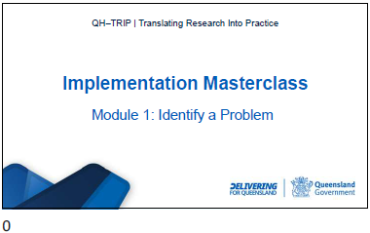

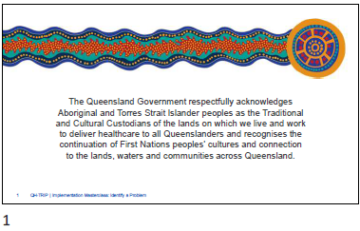

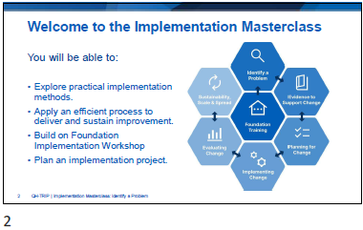

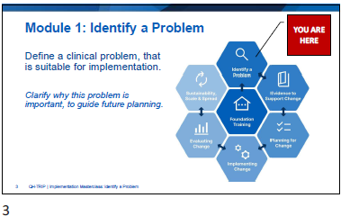

Slide | Notes
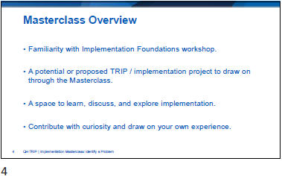

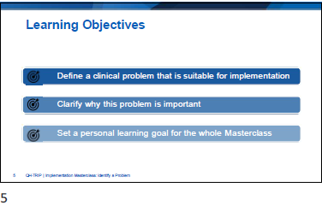
Template: My personal learning goal
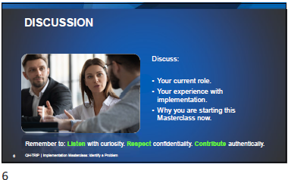

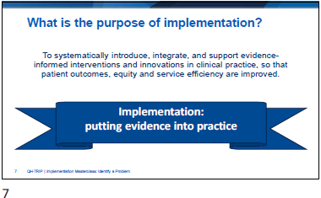

Slide | Notes
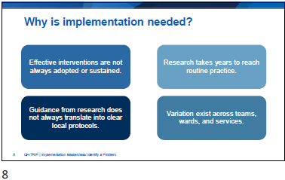

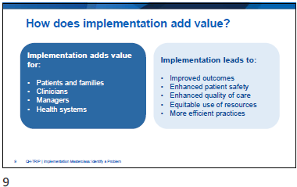

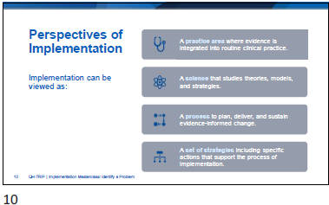

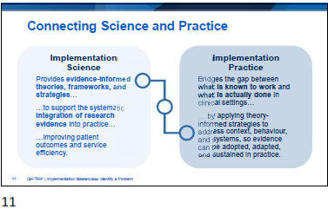

Slide | Notes
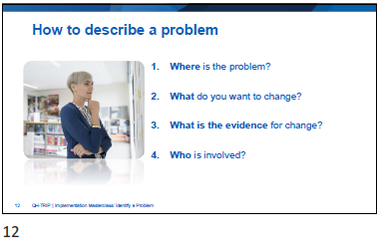

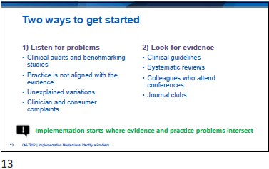

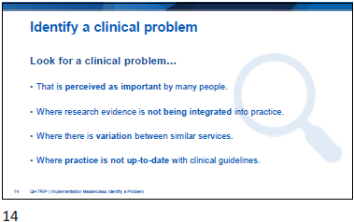

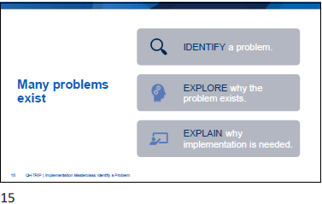

Slide | Notes
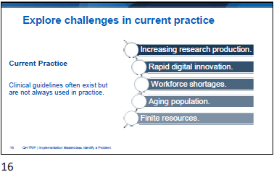

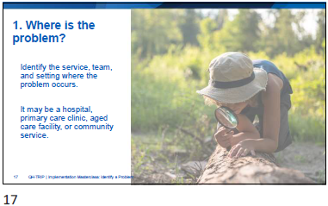

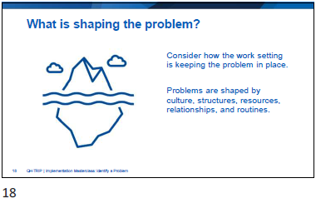

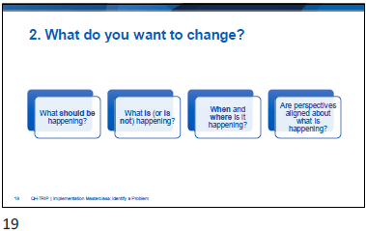

Slide | Notes
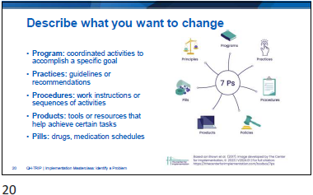

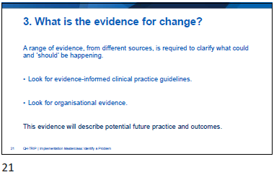

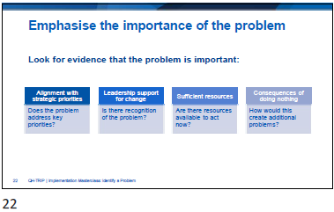

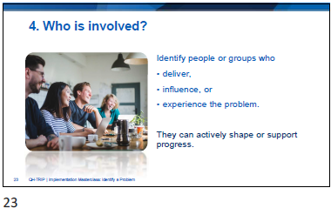

Slide | Notes
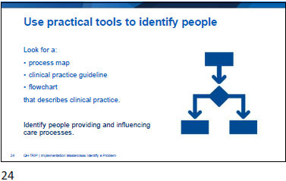

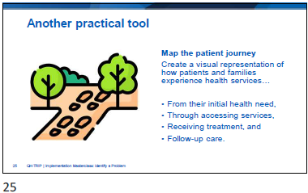

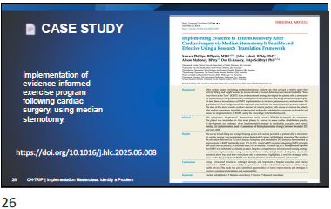

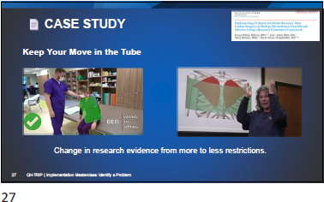

Slide | Notes
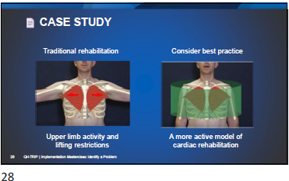

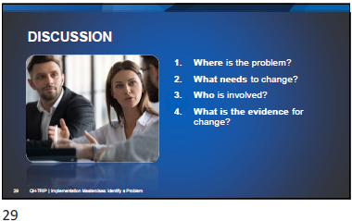
Activity 1: Describe the problem (case study)
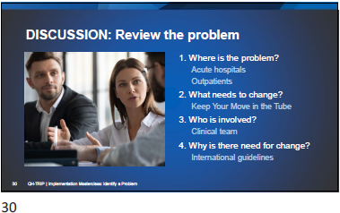

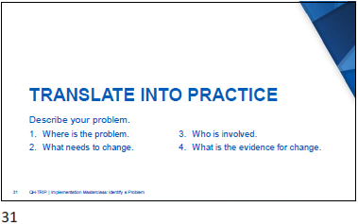
Activity 2: Describe the problem (TRIP)

Slide | Notes
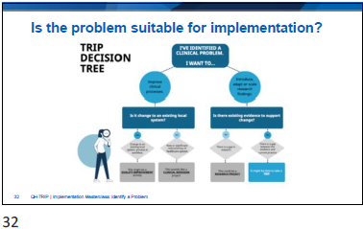
QH-TRIP Decision Tree: Identify a Problem
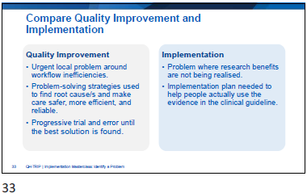

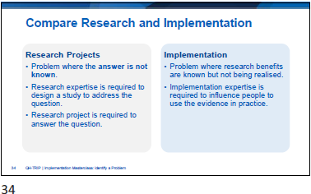

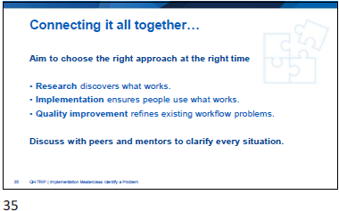

Slide | Notes
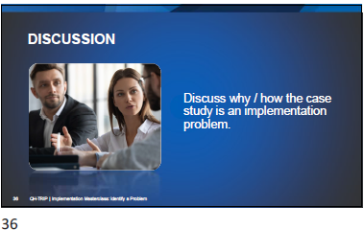

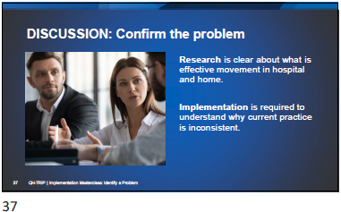

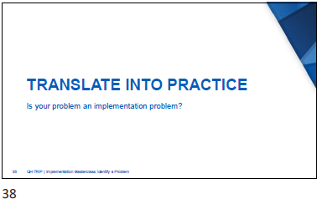

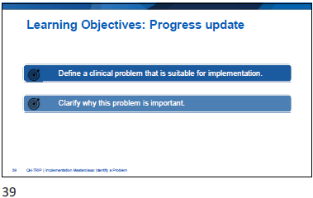

Slide | Notes
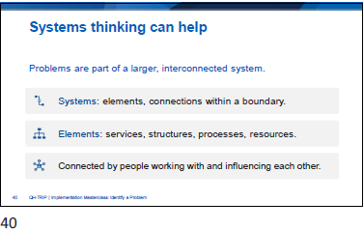

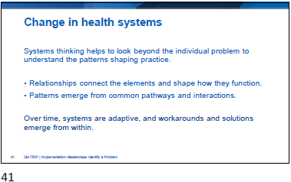

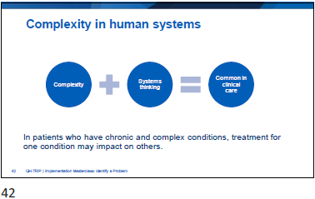

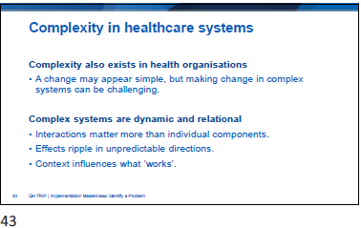

Slide | Notes
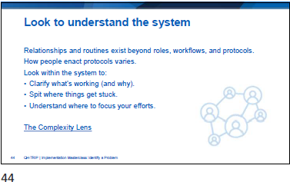

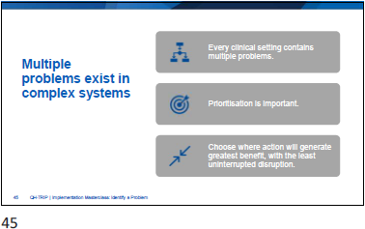

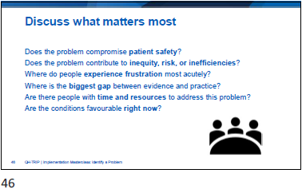

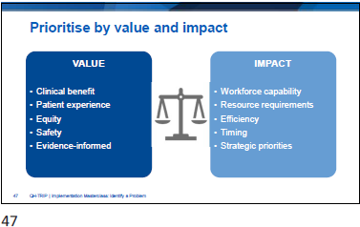

Slide | Notes
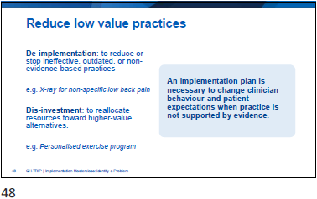

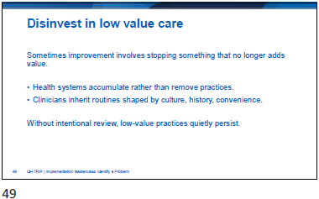

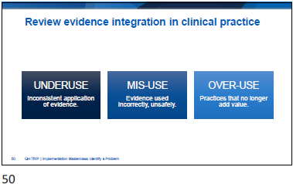

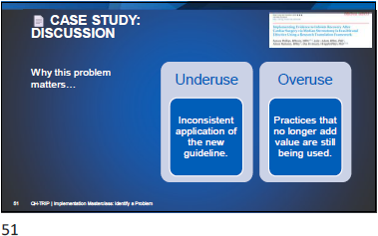

Slide | Notes

Activity 3: Discuss the importance of the problem
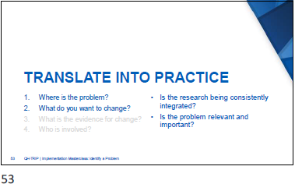
Activity 4: Reflection – Describe your own clinical problem
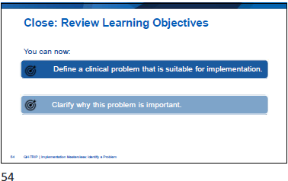

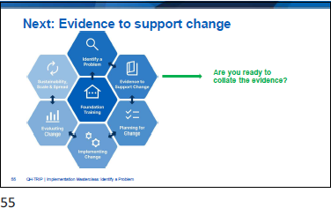

Slide | Notes
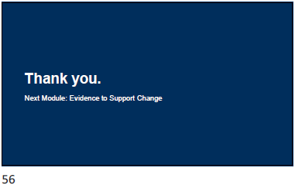



Appendix
- Template: My personal learning goal
- Activity 1: Describe the problem (case study)
- Activity 2: Describe the problem (TRIP)
- Activity 3: Discuss the importance of the problem
- Activity 4: Reflection – Describe your own clinical problem
- QH-TRIP Decision Tree: Identify a Problem

  - Template: My personal learning goal

My Personal Learning Goal | Date:

  - Activity 1: Describe the problem (case study)

- Where is the problem?
- What do you want to change?
- What is the evidence for change?
- Who is involved?

  - Activity 2: Describe the problem (TRIP)

- Where is the problem?
- What do you want to change?
- What is the evidence for change?
- Who is involved?

  - Activity 3: Discuss the importance of the problem

Parameters | Describe Local Problem
Does the problem compromise patient safety?
Does the problem contribute to inequity, risk or inefficiencies?
Where do people experience frustration most acutely?
Where is the biggest gap between evidence and practice?
Are there people with time and resources to address this problem?
Are the conditions favourable right now?

  - Activity 4: Reflection – Describe your own clinical problem

If you’ve identified your problem…
Where is the problem?
What do you want to change?
If you’re looking for a problem…
Is there a problem where research evidence is not being consistently integrated into practice?
Is this problem relevant and important?

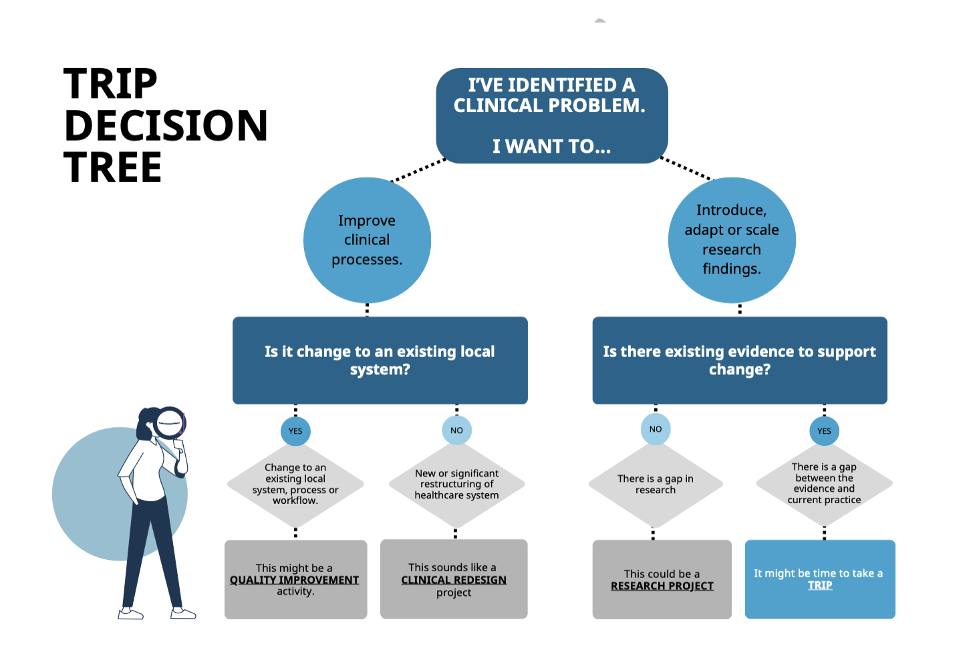
  - QH-TRIP Decision Tree: Identify a Problem

