QH-TRIP | Translating Research Into Practice

Implementation Foundations
An Introduction to Implementation
Participant Handbook
  - 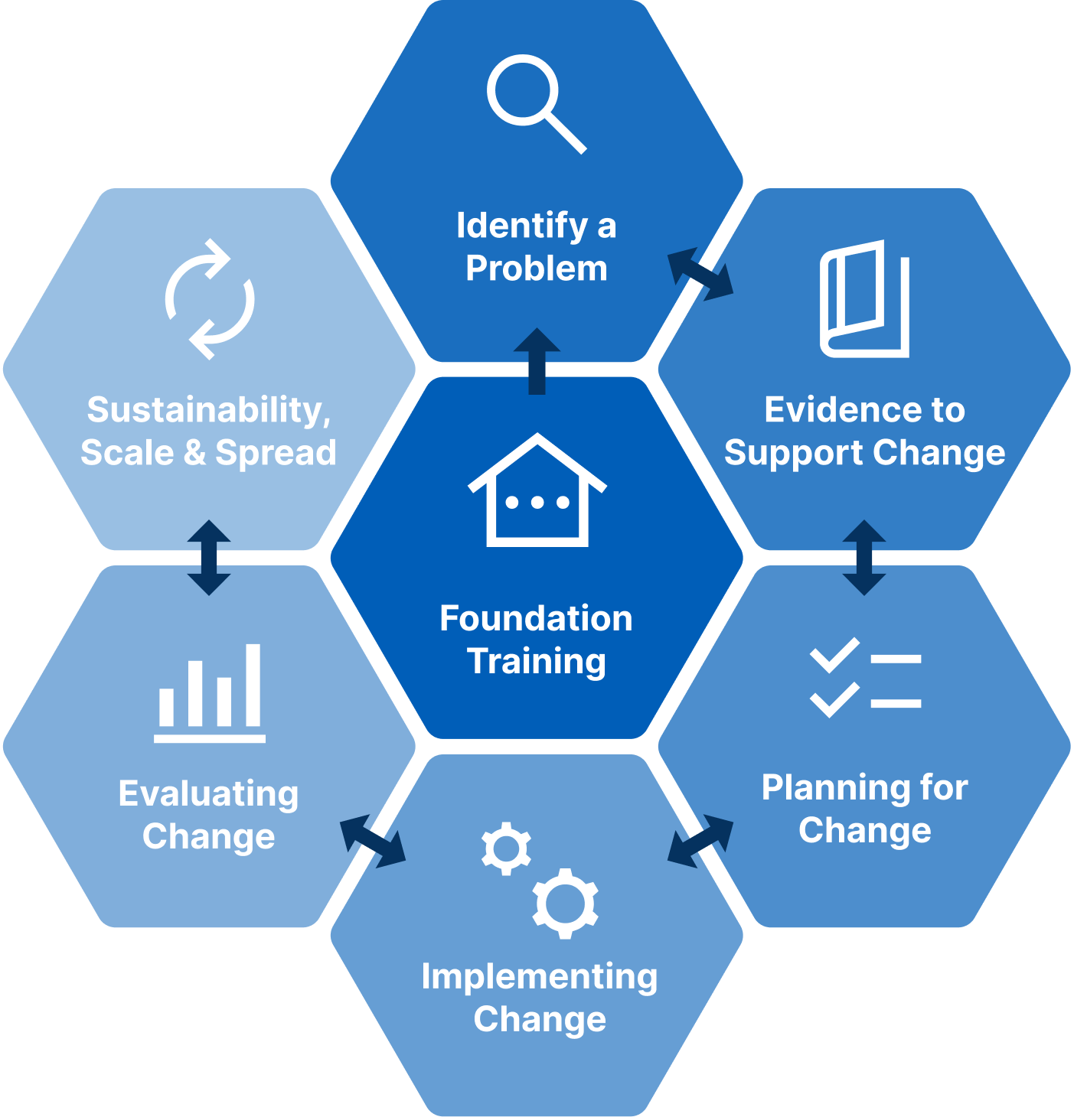

Implementation Foundations: An Introduction to Implementation Participant Handbook
Published by the State of Queensland (Queensland Health), June 2026

This document is licensed under a Creative Commons Attribution 4.0 International licence (CC BY 4.0). To view a copy of this licence, visit creativecommons.org/licenses/by/4.0/
You are free to copy, communicate and adapt the work, as long as you attribute the State of Queensland (Queensland Health).
For more information contact:
Office of the Chief Allied Health Officer (OCAHO), Health Workforce Division, Queensland Health, GPO Box 48, Brisbane QLD 4001, email allied_health_advisory@health.qld.gov.au, phone (07) 3328 9928.
Disclaimer
The content presented in this publication is distributed by the Queensland Government as an information source only. The State of Queensland makes no statements, representations or warranties about the accuracy, completeness of any information contained in this publication. The State of Queensland disclaims all responsibility and all liability (including without limitation for liability in negligence) for all expenses, losses, damages and costs you might incur as a result of the information.

Contents
Prelude 4
Helpful links and resources 5
Familiarise yourself with implementation 5
What are clinical practice guidelines? 5
A useful summary of clinical guidelines 5
Read the case study 5
Guideline Summary 6
Review the ERAS guidelines 6
Presentation slides 7
Appendices 37
A.1 Reflection – My Personal Learning Goal 38
A.2 Case study: Describe the evidence-practice gap 39
A.3 Case study: Mapping behaviour (Table 3) 40
A.4 Case study: Applying the COM-B 42
A.5 Case Study: Implementation Strategies 43
A.6 Reflection: Foundation Module Review 44
A.7 Template: Describe a Local Problem 45
A.8 Template: Discuss the importance of the problem 46
A.9 Template: Summarise the evidence-practice gap 47
A.10 Template: Stakeholder mapping 48
A.11 Template: TRIP Stakeholder Matrix 49
A.12 Template: Using the COM-B to explore behaviour change 50
A.13 Template: QH-TRIP Program Logic Model 51
A.14 Guide: QH-TRIP Program Logic Model 52
A.15 Guide: Comparing Quality Improvement, Research Projects, Clinical Redesign, and Implementation 53

Prelude
Welcome to the Implementation Foundations workshop.
This workshop is designed to introduce you to the purpose and practice of implementation, and to provide a clear overview of the key stages involved in turning evidence into everyday practice.
Many people are curious about implementation and wonder how to plan for change in our complex health systems. This workshop offers a structured way of thinking about implementation. It will help you make sense of the process, the people involved, and the decisions that shape success over time.
You will be introduced to the sequence and stages of the QH-TRIP implementation process and the reasons why careful planning, attention to context, and engagement with people matter. The focus is on understanding the whole journey, rather than mastering specific theories or tools. You will see how others develop and plan for implementation in a published case study.
You are not expected to identify your own clinical problem. Instead, this workshop provides shared language and a clear mental model that you can carry forward into future learning and practice. You will be encouraged to reflect on some of your own clinical challenges.
For many participants, this workshop is the first step in a longer learning pathway. Those who wish to deepen their understanding will go on to the Implementation Masterclass, where each stage of the process is explored in more detail using a worked case study, practical strategies, and reflective activities.
Our aim is that you leave this workshop feeling oriented, reassured, and better equipped to recognise where you are in the implementation journey, and what your next step might be.

Helpful links and resources

Implementation
Familiarise yourself with implementation | Implementation science: What is it and why should I care? (Bauer & Kirchner, 2020).  An introduction to implementation science for the non-specialist. (Bauer et al., 2015).  Implementation science: A critical but undervalued part of the healthcare innovation ecosystem. (Chan et al., 2022).
An interesting paper about language | Concept analysis of health research translation nomenclature. Lizarondo et al., 2025).
Listen to a podcast conversation | An implementation scientist and clinical nurse specialist compare their journeys into using implementation (hosted by the Swiss Learning Health System)  https://youtu.be/sXS6iYIeGZw?si=Irbn9awc5uCZkjnt
Read about practice examples of implementation | What Can Implementation Science Do for You? Key Success Stories from the Field. (Kilbourne, Glasgow, & Chambers, 2020).

The Knowledge to Action (KTA) framework
The KTA framework – the seminal article | Lost in knowledge translation: Time for a map? (Graham et al., 2006).
A recent summary article | Creating system-wide change in medicine: The role of implementation science in achieving scale and adoption. (Barry & Davies, 2025).

Clinical practice guidelines
What are clinical practice guidelines? | What are clinical practice guidelines? (Queen Margaret University, Edinburgh)
A useful summary of clinical guidelines | Developing and Implementing Clinical Guidelines (Agency for Clinical Innovation NSW Health)

The case study
Read the case study | Implementing early feeding after liver transplant using implementation frameworks: A multimethod study. (Takefala et al., 2025).

Explanations of Enhanced Recovery after Surgery (ERAS)
Explanations of Enhanced Recovery after Surgery (ERAS) evidence and practice | Enhanced Recovery After Surgery. (Parks, Routt, & De Villiers, 2018).  Revolutionizing surgical care: The power of Enhanced Recovery After Surgery (ERAS). (Mithany et al., 2023).
Guideline Summary | Early oral feeding after colorectal surgery: A mixed methods study of knowledge translation. (Robertson et al., 2018).
Review the ERAS guidelines | Guidelines for perioperative care for liver transplantation: Enhanced Recovery After Surgery (ERAS) recommendations. (Brustia et al., 2022).

COM-B
Familiarise yourself with the COM-B model | Why Are There Different Versions of the COM-B Model Diagram? - Article (v1). West & Michie, 2023).  Susan Michie on Behavioral Change. (Social Science Bites, 2020).  The COM-B Website  The COM-B Model for Behavior Change (The Decision Lab).

The Theoretical Domains Framework (TDF)
The TDF – the seminal article | A guide to using the Theoretical Domains Framework of behaviour change to investigate implementation problems. (Atkins et al., 2017).
Revisit and understand the TDF | What is the Theoretical Domains Framework (TDF)? (Moore, 2025).

Organisational Context
Mapping barriers and enablers to behaviour change | Organizational contextual features that influence the implementation of evidence-based practices across healthcare settings: a systematic integrative review. (Li et al., 2018).

Sustainability
The five components of sustainability – the seminal paper | Developing a comprehensive definition of sustainability. (Moore et al., 2017).

Presentation slides
Slide | Notes
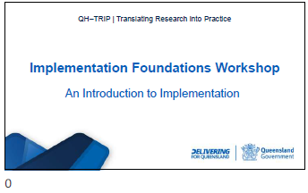

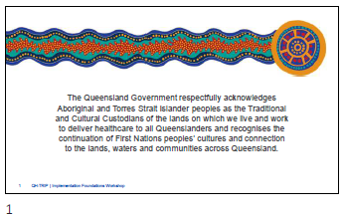

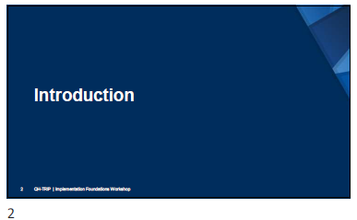
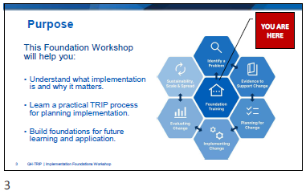

Slide | Notes
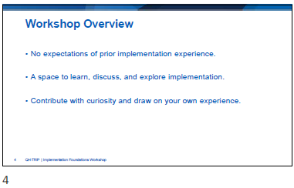

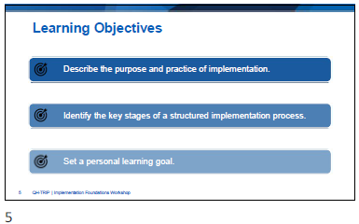
Reflection – My Personal Learning Goal
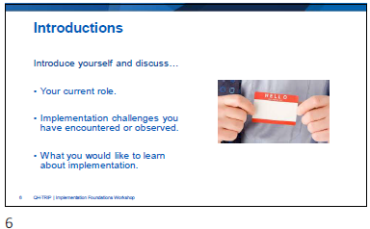

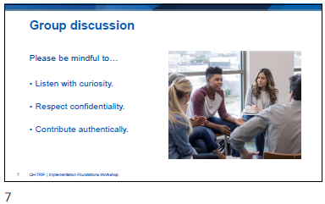

Slide | Notes
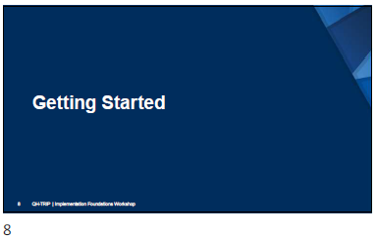
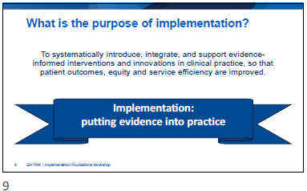

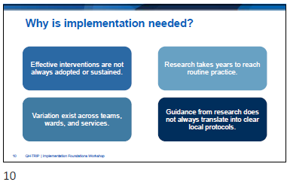

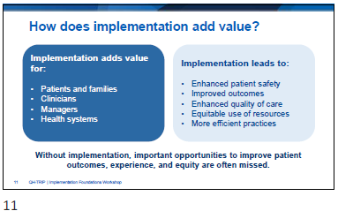

Slide | Notes
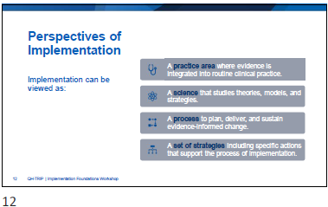

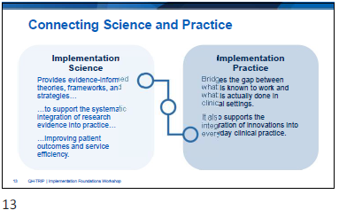

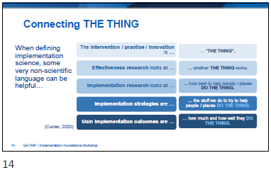

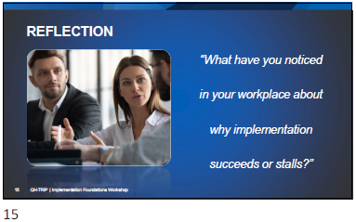

Slide | Notes
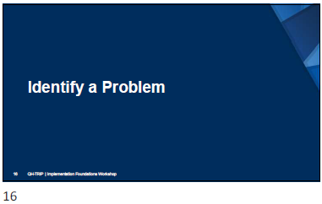

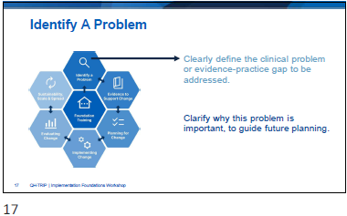

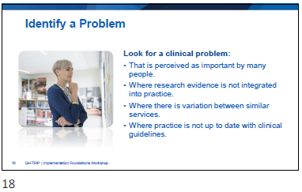
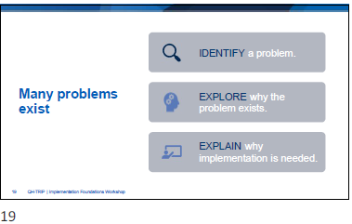

Slide | Notes
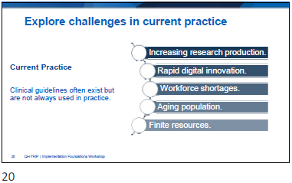

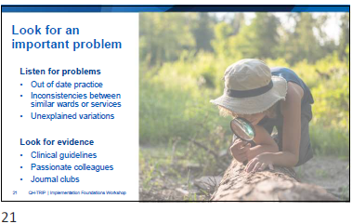

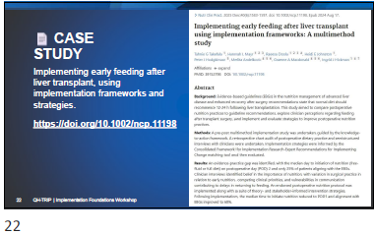
Journal: https://doi.org/10.1002/ncp.11198
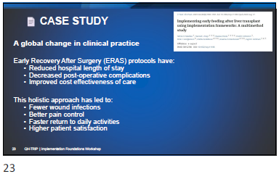

Slide | Notes
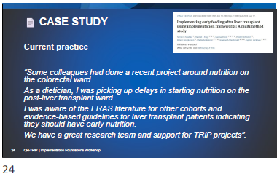

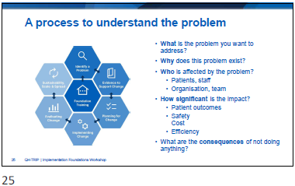

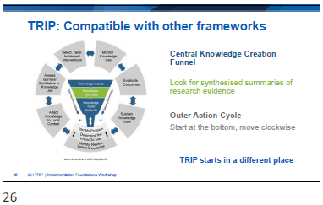

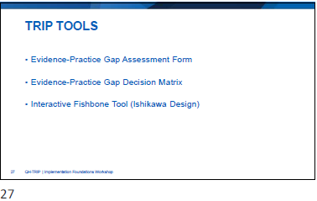

Slide | Notes
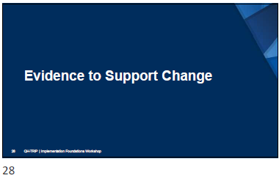

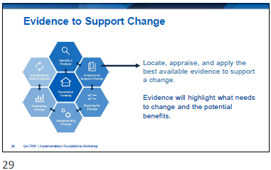

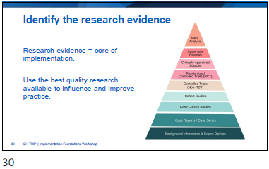

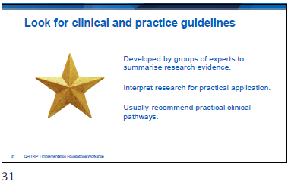

Slide | Notes
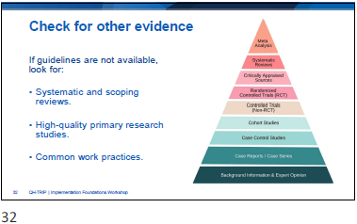

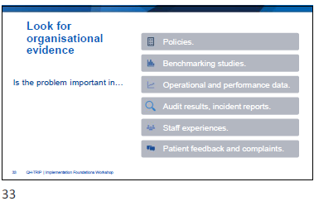

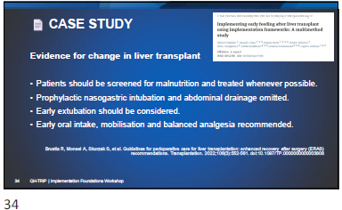
Journal: https://doi.org/10.1002/ncp.11198
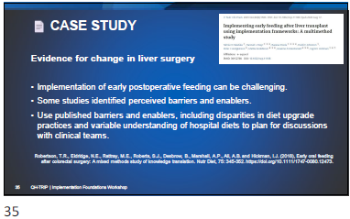

Slide | Notes
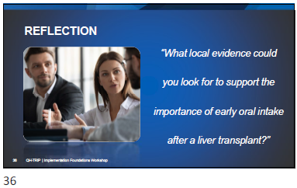
Case study: Describe the evidence-practice gap
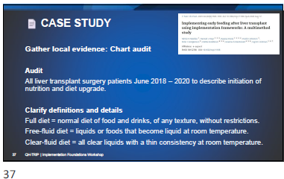

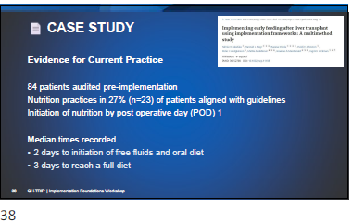

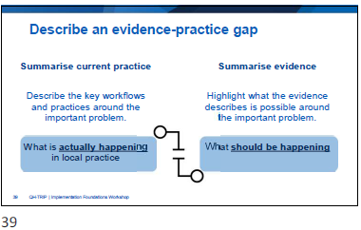

Slide | Notes
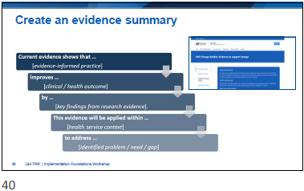

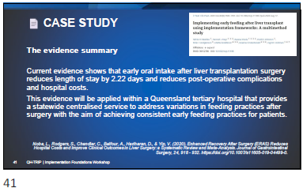

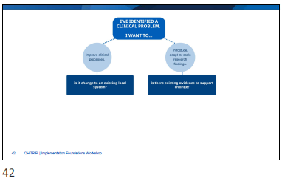

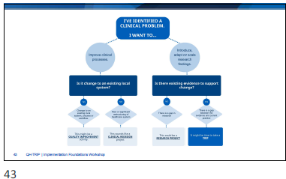

Slide | Notes
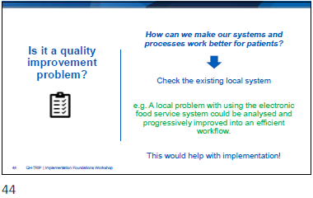

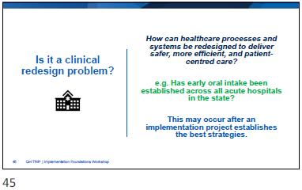

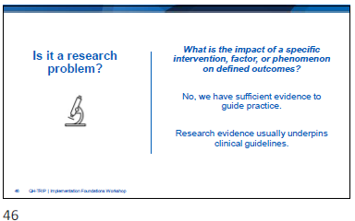

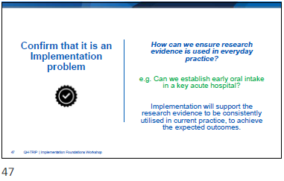

Slide | Notes
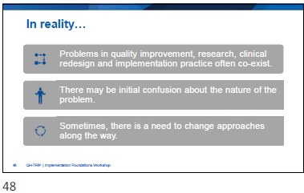

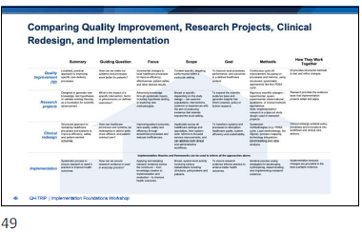

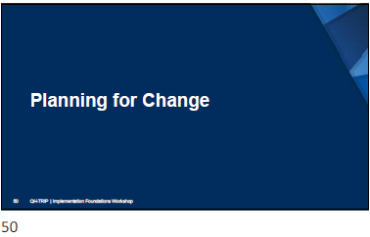

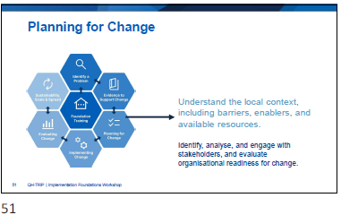

Slide | Notes
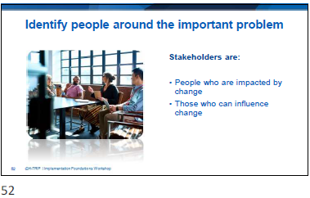

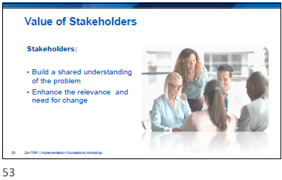

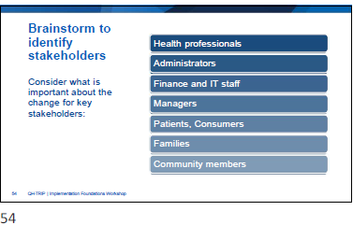

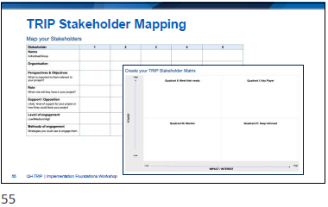

Slide | Notes
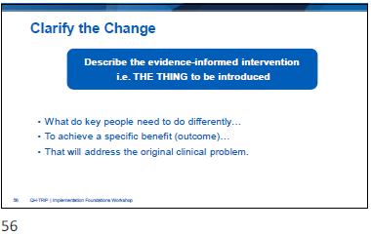

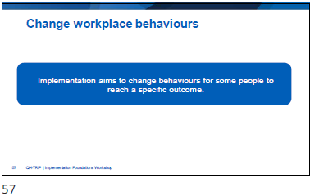

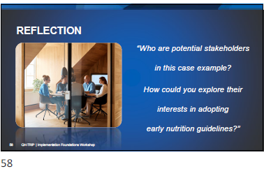

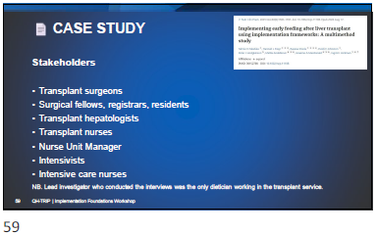

Slide | Notes
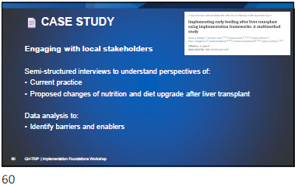

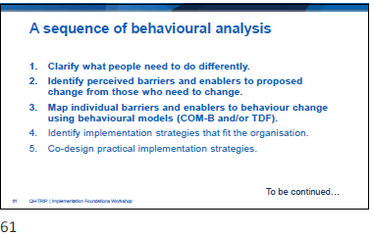

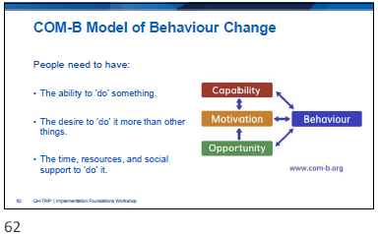

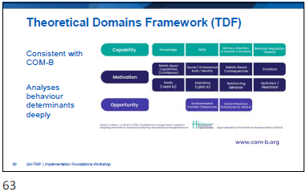

Slide | Notes
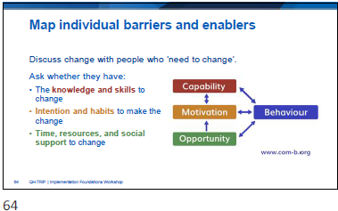

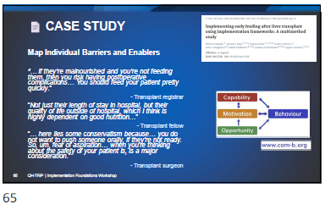

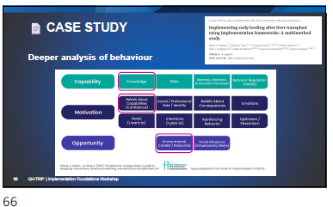

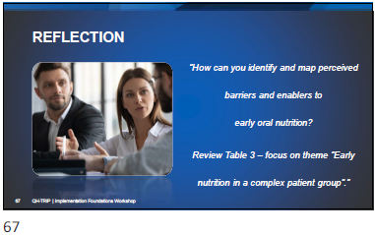
Case study: Mapping behaviour (Table 3)

Slide | Notes
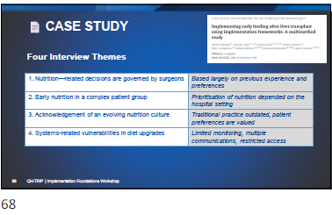

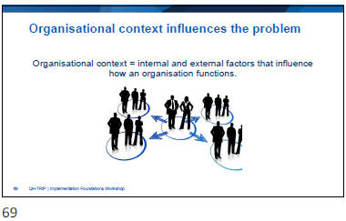

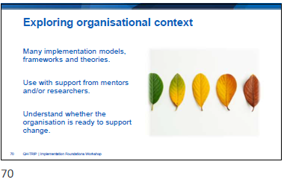

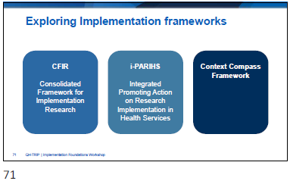

Slide | Notes
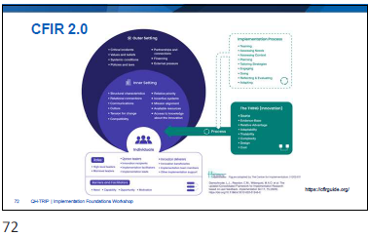
Link: https://cfirguide.org/
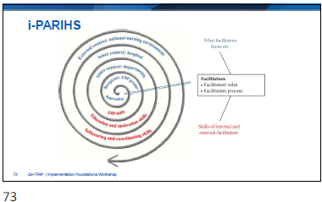

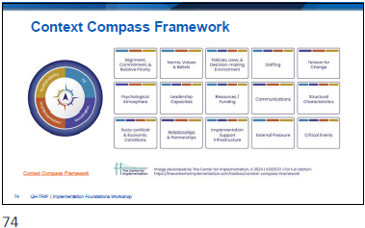

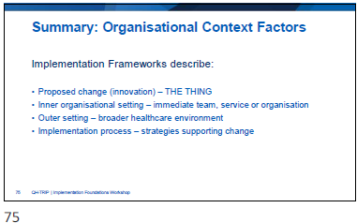

Slide | Notes
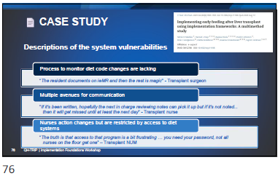

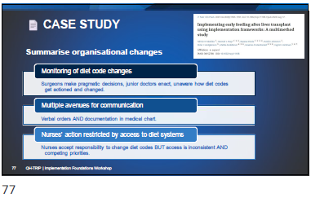
Case study: Mapping behaviour (Table 3)
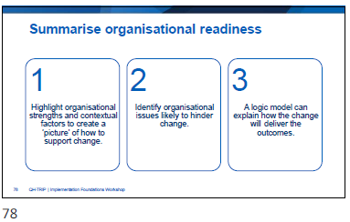

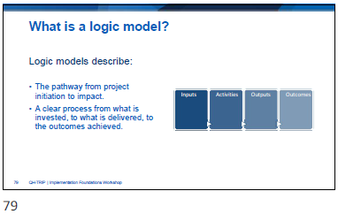

Slide | Notes
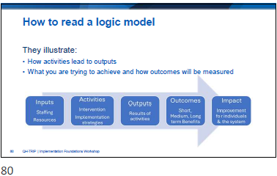

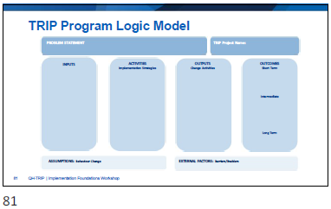

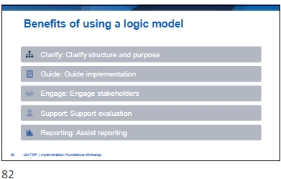

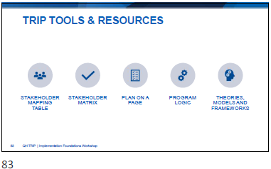

Slide | Notes
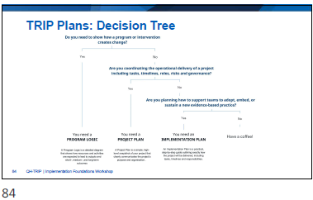

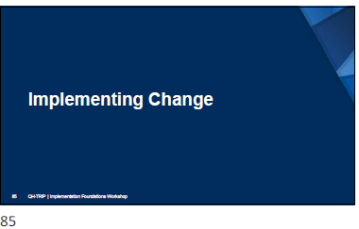

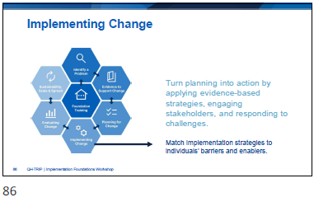

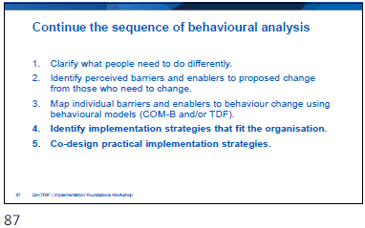

Slide | Notes
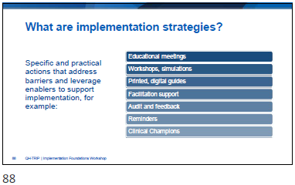

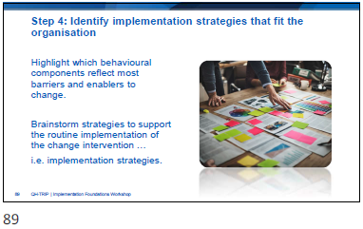

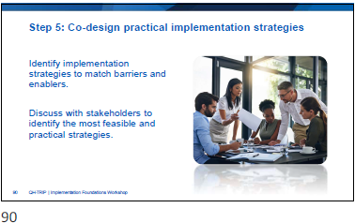

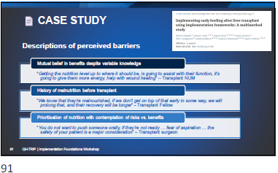

Slide | Notes
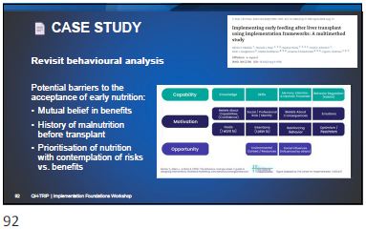
Case study: Applying the COM-B
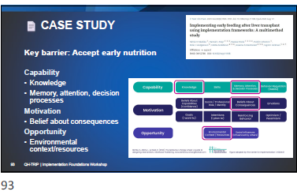

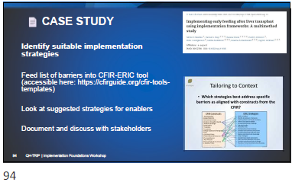
Link: https://cfirguide.org/cfir-tools-templates
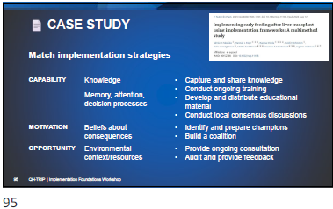

Slide | Notes
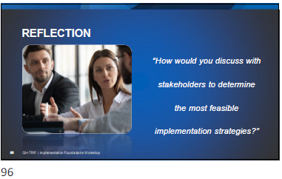
Case Study: Implementation Strategies
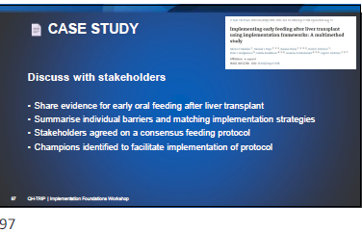

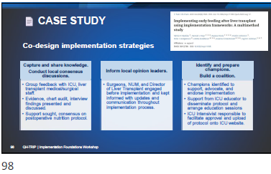

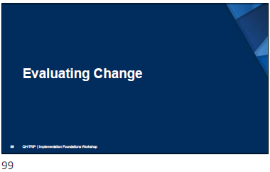

Slide | Notes
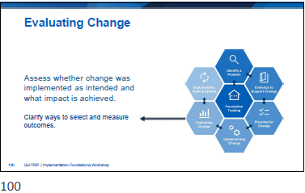

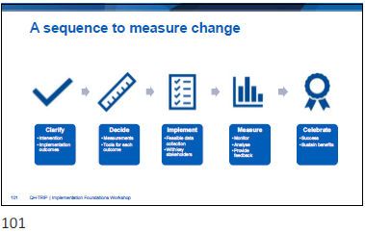

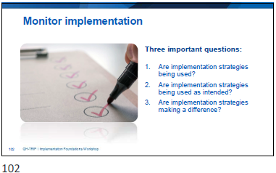

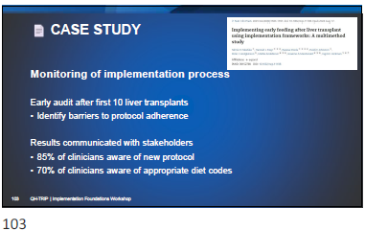

Slide | Notes
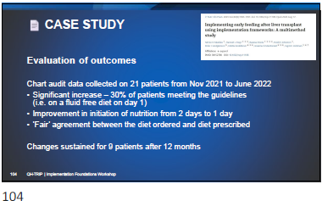

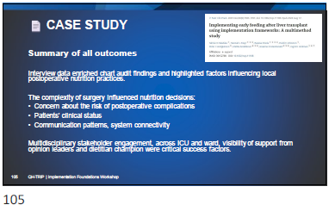

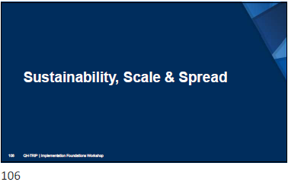

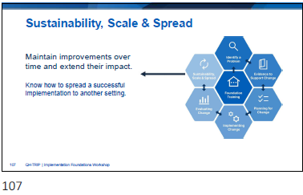

Slide | Notes
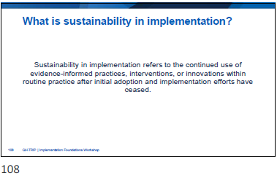

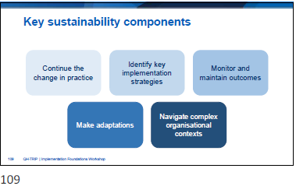

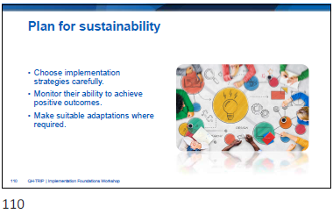

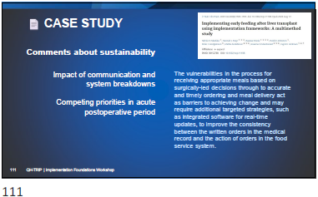

Slide | Notes
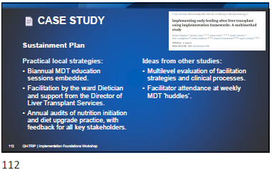

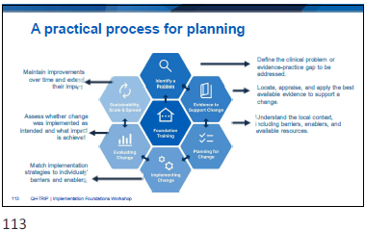

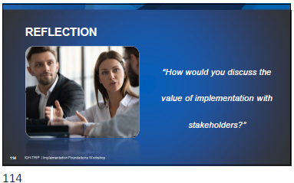

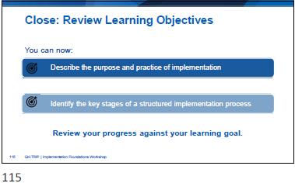
Reflection: Foundation Module Review

Slide | Notes


Appendices

Reflection: My Personal Learning Goal

Case study: Describe the evidence-practice gap
- Case study: Mapping behaviour

Case study: Applying the COM-B

Case Study: Implementation Strategies

Reflection: Foundation Module Review

Template: Describe a Local Problem

Template: Discuss the importance of the problem

Template: Summarise the evidence-practice gap

Template: Using the COM-B to explore behaviour change

Template: Stakeholder mapping

Template: TRIP Stakeholder Matrix

Template: QH-TRIP Program Logic Model

Guide: QH-TRIP Program Logic Model
- Guide: Comparing Quality Improvement, Research Projects, Clinical Redesign, and Implementation

  - Reflection – My Personal Learning Goal

My Personal Learning Goal | Date:

  - Case study: Describe the evidence-practice gap

Describe the Problem
Summarise the research evidence
Describe current practice
Summarise the Evidence-Practice Gap
Current evidence shows that …. | evidence-informed practice
improves …. | clinical/health outcome
by …. | benefit described in research evidence
This evidence will be applied within …. | specific health service
to address …… | important problem
with the aim of achieving….. | intended improvement

  - Case study: Mapping behaviour (Table 3)

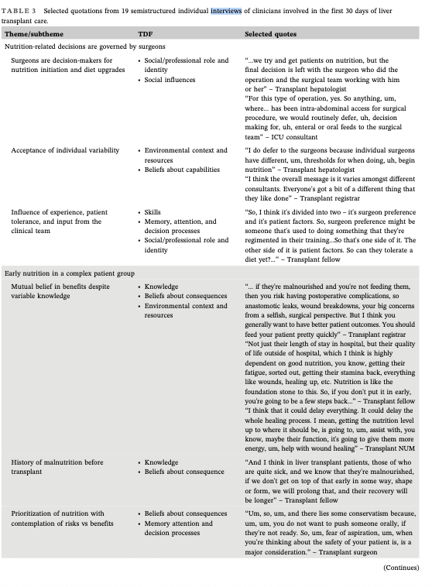

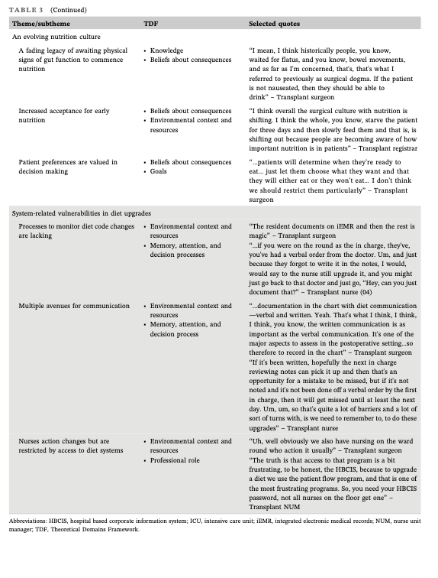

  - Case study: Applying the COM-B

Identify the Stakeholders
Identify Stakeholders
How did they engage with them?
Identify Barriers & Enablers
Analyse Barriers & Enablers: Use COM- B Model
The capability to ‘do’ something
The desire to ‘do’ it more than other things
Time, resources and social support to ‘do’ it
Describe the Organisational Context
  - Case Study: Implementation Strategies

Identify implementation strategies
Monitor and Evaluate Outcomes
Monitor Implementation Process
Evaluate Intervention Outcome
Evaluate Implementation Outcomes
Summarise sustainability

  - Reflection: Foundation Module Review

Review my Personal Learning Goal
Which stage of the implementation process feels most relevant right now?
Notes: Future Plans

  - Template: Describe a Local Problem

- Where is the problem?

- What do you want to change?

- What is the evidence for change?

- Who is involved?

  - Template: Discuss the importance of the problem

Parameters | Describe the local problem
Does the problem compromise patient safety?
Does the problem contribute to inequity, risk or inefficiencies?
Where do people experience frustration most acutely?
Where is the biggest gap between evidence and practice?
Are there people with time & resources to address this problem?
Are the conditions favourable right now?

  - Template: Summarise the evidence-practice gap

Current evidence shows that …. | evidence-informed practice
improves …. | clinical/health outcome
by …. | benefit described in research evidence
This evidence will be applied within …. | specific health service
to address …… | important problem
with the aim of achieving….. | intended improvement

  - Template: Stakeholder mapping
Stakeholder | 1 | 2 | 3 | 4 | 5
Name
Individual/Group
Organisation
Perspectives & Objectives
What is important to them relevant to your project?
Role
What role will they have in your project?
Support / Opposition
Likely level of support for your project or how they could block your project
Level of engagement
Low/Medium/High
Methods of engagement
Strategies you could use to engage them

  - Template: TRIP Stakeholder Matrix

Communication strategy:  Actively monitor and consult  Invite input early, communicate regularly | HIGH POWER  HIGH INTEREST | LOW POWER  HIGH INTEREST | Communication strategy:  Empower, involve, inform  Update regularly and invite to contribute to working groups
Local stakeholders: |  | Local stakeholders:
Communication strategy:  Keep satisfied and informed  Provide summary updates aligned with strategic priorities | HIGH POWER  LOW INTEREST | LOW POWER  LOW INTEREST | Communication strategy:  Monitor with minimal effort  Keep informed with general summaries and updates
Local stakeholders: |  | Local stakeholders:

  - Template: Using the COM-B to explore behaviour change

COM-B | Sample questions | Local questions
Capability | Do you have the physical skills required?
Capability | What do you need to learn more about?
Capability | Do you understand the reason for change?
Motivation | Do you believe you can do this well?
Motivation | Will it make a difference, for you, your patients?
Motivation | Will this change fit in with existing habits, processes?
Opportunity | Is there sufficient time, resources & space for change?
Opportunity | Is there a new tool/template?
Opportunity | Does everyone think it is a good idea?

  - Template: QH-TRIP Program Logic Model
PROBLEM STATEMENT: |  |  | TRIP PROJECT NAME:
INPUTS | ACTIVITIES  Implementation Strategies | OUTPUTS  Change Activities | OUTCOMES  Short Term
INPUTS | ACTIVITIES  Implementation Strategies | OUTPUTS  Change Activities | Intermediate
INPUTS | ACTIVITIES  Implementation Strategies | OUTPUTS  Change Activities | Long Term
ASSUMPTIONS: Behaviour Change |  | EXTERNAL FACTORS: Barriers/Enablers
  - Guide: QH-TRIP Program Logic Model
PROBLEM STATEMENT  Describe the evidence-practice gap this project seeks to address.  Identify why the project is needed, drawing on research evidence, local data, and stakeholder perspectives. |  |  | TRIP PROJECT NAME  What is the ‘thing’ you are implementing?
INPUTS  The things you invest in to make the project possible.  Stakeholders  e.g. patients, staff, project team, leaders, external partners.  Internal Factors/Organisational Context  e.g. culture and readiness, leadership support, infrastructure, resources, policies and procedures.  Implementation process  e.g. strategies, structures and mechanisms to facilitate the ‘thing’.  Innovation Characteristics  e.g. evidence strength and quality, advantages/disadvantages, adaptability, complexity, compatibility.  System-Level Factors  e.g. policy directives, professional guidelines, financing, performance targets, strategic alignment, partnerships. | ACTIVITIES  Implementation Strategies  The actions, strategies, or interventions you will carry out to implement the evidence into practice.  e.g. staff training, workflow redesign, stakeholder engagement, audit and feedback. | OUTPUTS  Change Activities  The specific activities you will undertake, guided by your chosen implementation strategies.  e.g. staff training sessions, handouts  Note! Movement between activities, outputs, and outcomes is dynamic, with feedback loops created through adaptation, learning, and monitoring. | OUTCOMES  Short Term  Immediate changes in knowledge, skills or awareness.
Intermediate
Changes in behaviour, policy, or service delivery.
Long Term
Ultimate impacts such as improved patient outcomes, system efficiency, or sustainability of evidence use.
ASSUMPTIONS: Behaviour Change  Conditions that must hold true for activities to lead to outcomes.  e.g. Training staff will increase their confidence to use the guidelines. |  | EXTERNAL FACTORS: Barriers/Enablers  Conditions outside the project’s control that may influence success.  e.g. organizational culture, leadership support, policy change, workforce pressures.

QH-TRIP | Translating Research Into Practice
  - Guide: Comparing Quality Improvement, Research Projects, Clinical Redesign, and Implementation
 | Summary | Guiding Question | Focus | Scope | Goal | Methods | How They Work Together
Quality Improvement (QI) | Localised, practical approach to improving specific care delivery processes. | How can we make our systems and processes work better for patients? | Incremental changes to local healthcare processes to improve efficiency, effectiveness, patient safety and other desired results. | Context-specific, targeting performance within a particular setting. | To improve local processes, performance, and outcomes in a defined healthcare context. | Continuous cycle of improvement, focusing on processes and metrics, using structured, systematic approaches like the PDSA cycle. | QI provides structured methods to test and refine changes.
Research projects | Designed to generate new knowledge, test hypotheses or validate existing theories, as a foundation for scientific advancement. | What is the impact of a specific intervention, factor or phenomenon on defined outcomes? | Advancing knowledge through systematic inquiry, including hypothesis testing, or exploring new methodologies. | Broad or specific, depending on the study design – can examine populations, interventions, systems or experiences with the aim of producing evidence that extends beyond the local setting. | To expand the scientific evidence base and generate insights that inform practice, policy or further research. | Rigorous scientific designs – experimental, quasi-experimental, observational, qualitative, or mixed methods approaches.  Note: Implementation research is a type of study design used in research projects. | Research provides the evidence base that implementation projects adapt and apply.
Clinical redesign | Structured approach to reshaping healthcare processes and systems to improve efficiency, safety, and patient-centred outcomes. | How can healthcare processes and systems, be redesigned to deliver safer, more efficient, and patient-centred care? | Improving patient outcomes, care quality, safety and efficiency through streamlined processes and reduced inefficiencies. | Applicable across all healthcare settings and specialties, from system-wide reforms to focused service improvements, and can address both clinical and administrative workflows. | To transform systems and processes to strengthen healthcare quality, system efficiency and sustainability. | Systematic methodologies (e.g. PDSA cycle, Lean methodology, Six Sigma); process mapping; technology integration; benchmarking and data analysis. | Clinical redesign embeds policy, processes and innovations into workflows and clinical care delivery.
Implementation | Implementation theories and frameworks can be used to inform all the approaches above.
Implementation | Systematic process to ensure research is used in practice to improve health outcomes. | How can we ensure research evidence is used in everyday practice? | Applying and adapting research evidence across the continuum – from knowledge creation to implementation and evaluation – to improve health outcomes. | Broad, system-level activity involving various stakeholders including clinicians, policymakers and patients. | To ensure research evidence informs practice to achieve better health outcomes. | Iterative process using strategies for developing, synthesising, disseminating, and implementing research evidence. | Implementation ensures changes are grounded in the best available evidence.

