Queensland Government

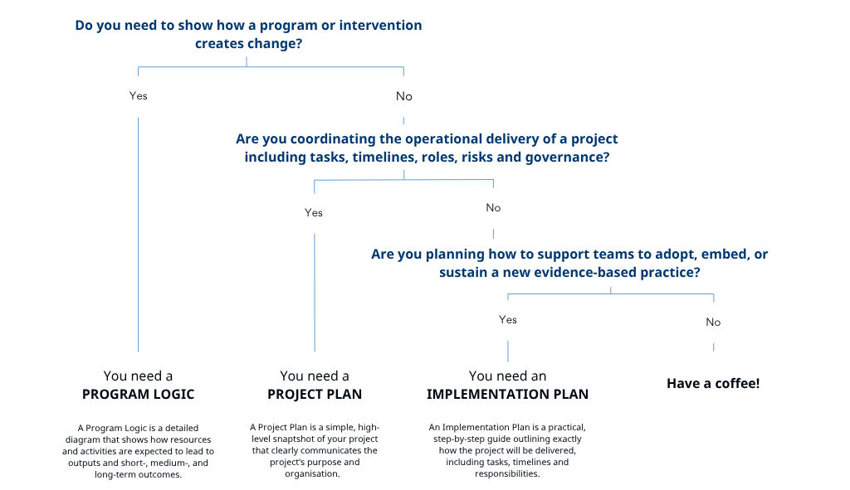
TRIP Plans
QH-TRIP | Translating Research Into Practice

